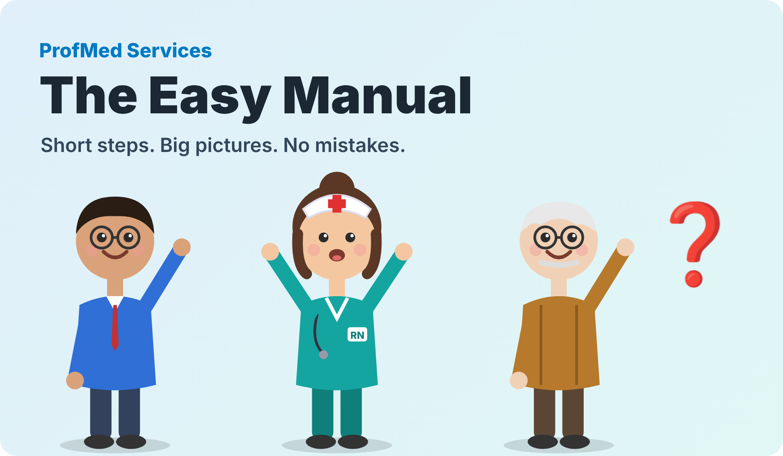
ProfMed Services — The Easy Manual
For agency offices, nurses and therapists. Read the pictures from left to right, top to bottom.
Version 1.0 · October 2026
Meet the team in the pictures: Rita the nurse 👩‍⚕️, Sam from the office 👨‍💼, and Mr. Test, our fake patient 👴. All names and data in this manual are fake.

What is inside
🚪 | Part 1 Start here | Everyone
❓ | Part 2 Lost? Press ❓ | Everyone
🧑‍🦳 | Part 3 Add a patient | Office
📝 | Part 4 Give a job to a nurse | Office
🧭 | Part 5 Watch the day | Office
🩺 | Part 6 Your visit, step by step | Nurses and therapists
⏺ | Part 7 Fill the paper by voice | Nurses and therapists
🧍 | Part 8 OASIS: 5 big questions | Nurses and therapists
✍️ | Part 9 Two signatures, then done | Nurses and therapists
🛡 | Part 10 10 rules to avoid mistakes | Everyone
Tip: in ProfMed, the round ❓ button (bottom right of every page) shows the same steps for the page you are on.

🚪 Part 1
Start here
For: Everyone

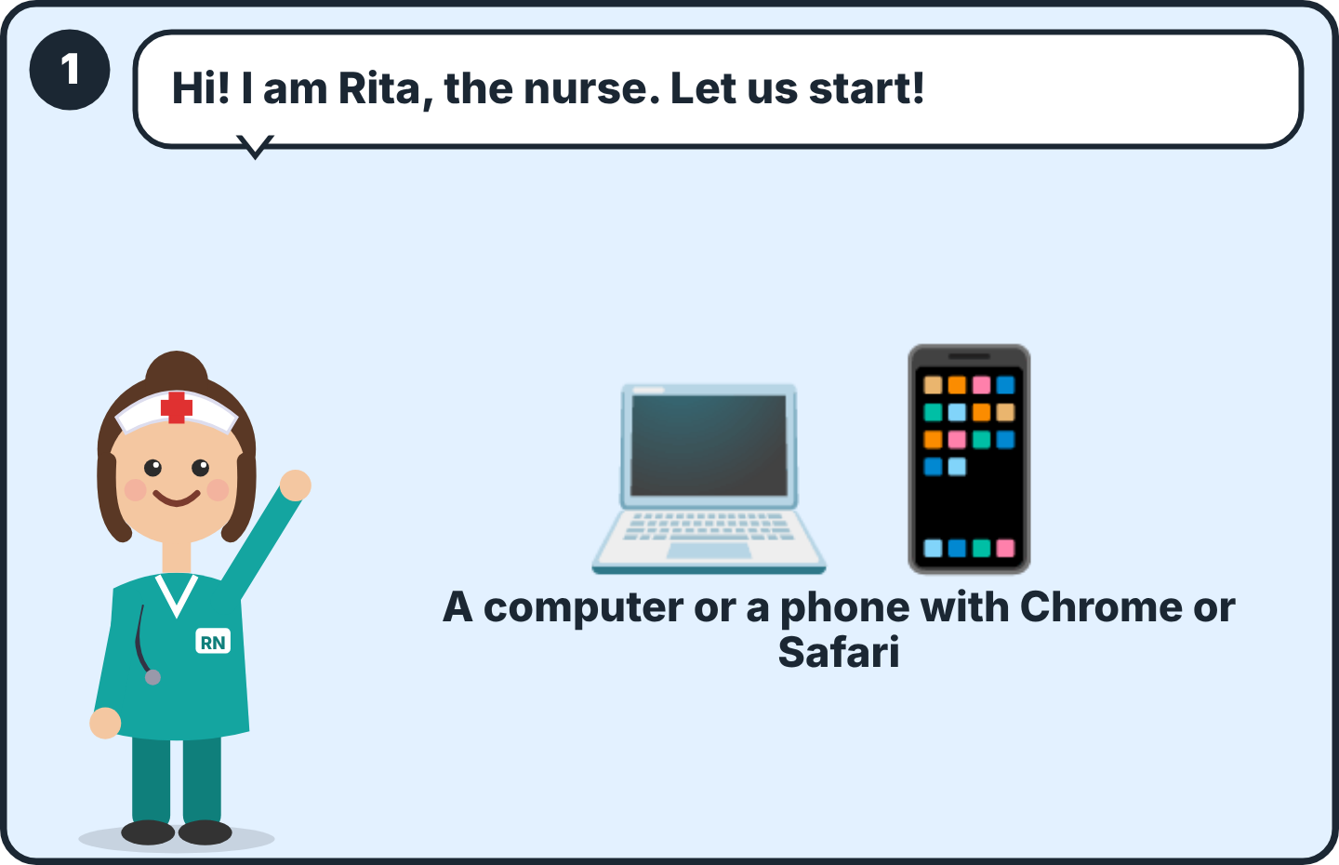  1 Use a computer or a phone. Open the ProfMed link your office gave you (today: profmedservices-api.fly.dev/app). | 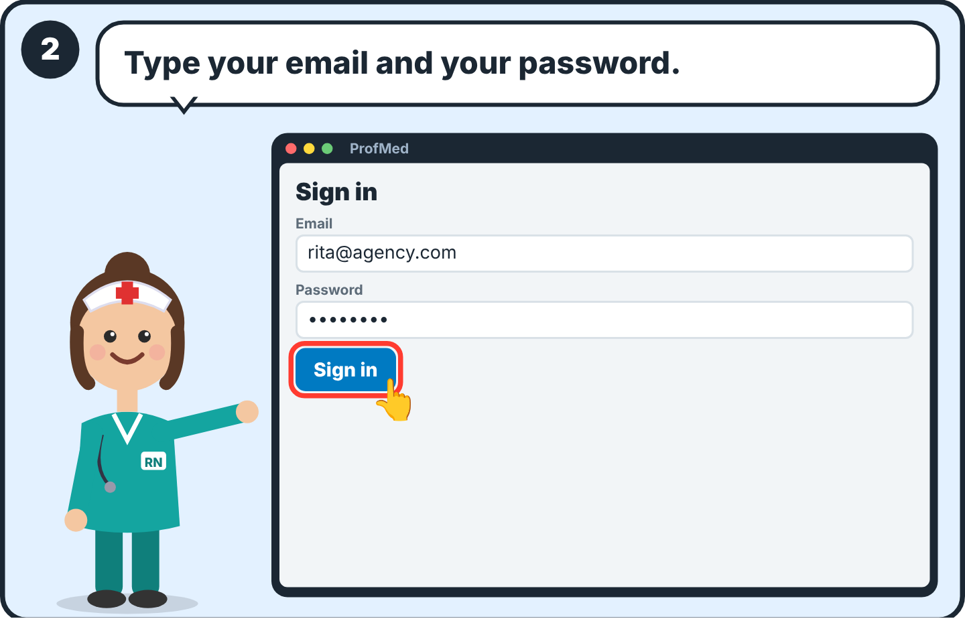  2 Type your email and password. Press Sign in. Never give your password to anyone.
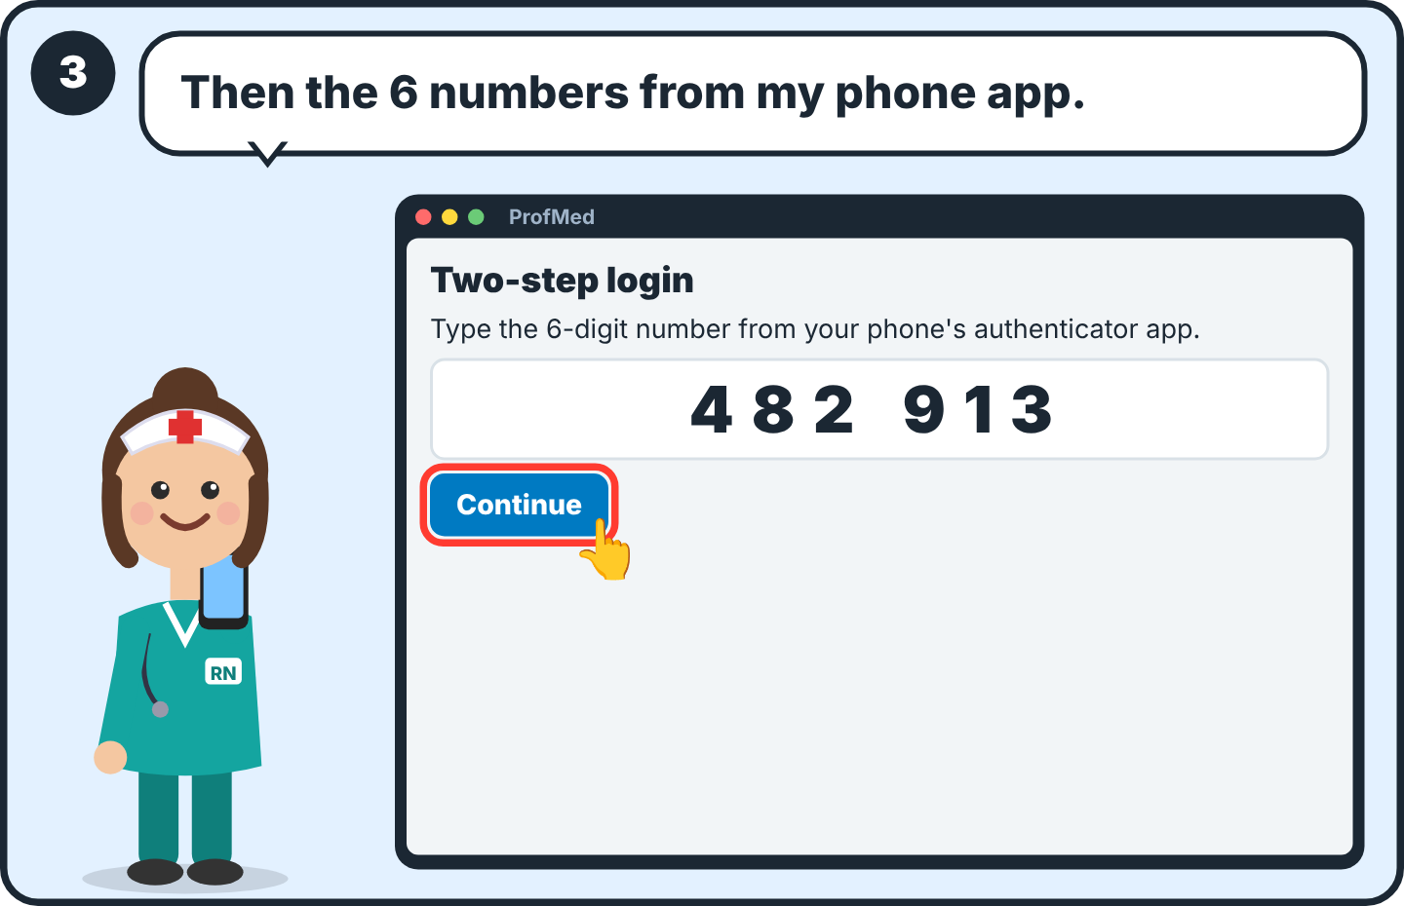  3 Open the code app on your phone (two-step login). Type the 6 numbers. The numbers change every 30 seconds. | 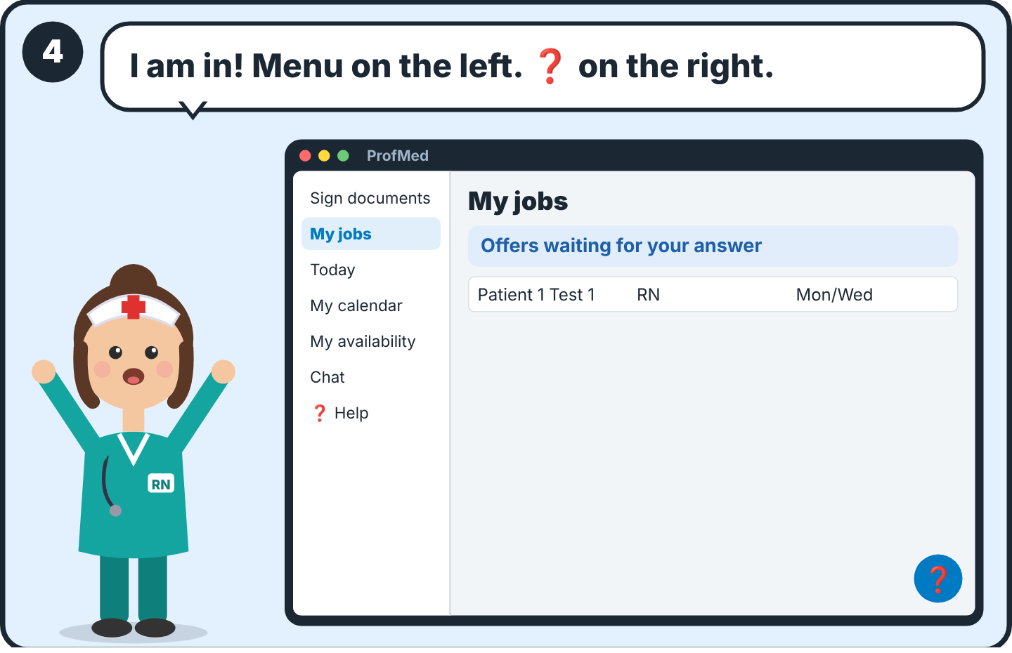  4 You are in. The menu is on the left (on a phone: press Menu). The round ❓ button is always at the bottom right.

❓ Part 2
Lost? Press ❓
For: Everyone

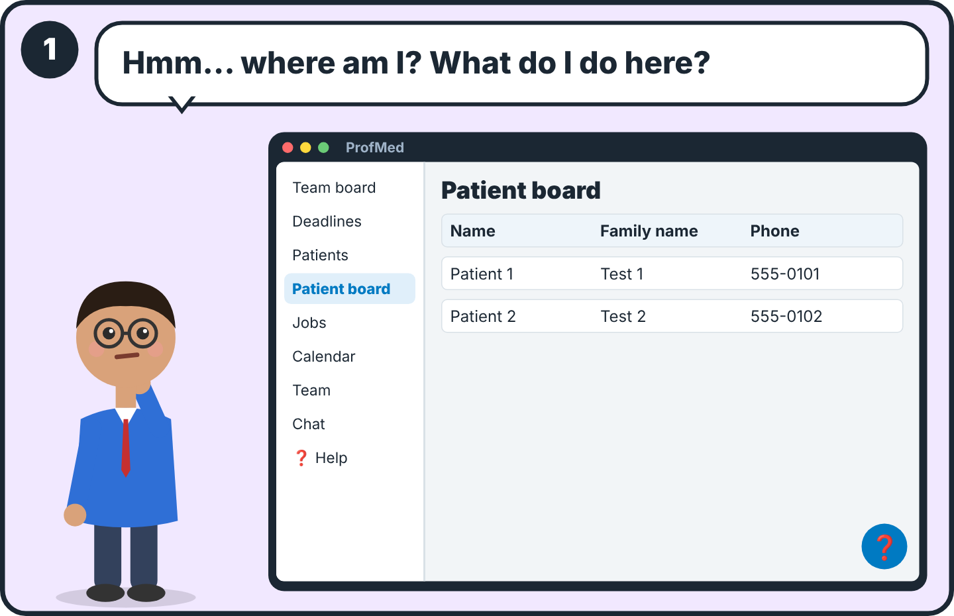  1 Not sure what a page does? Do not guess. | 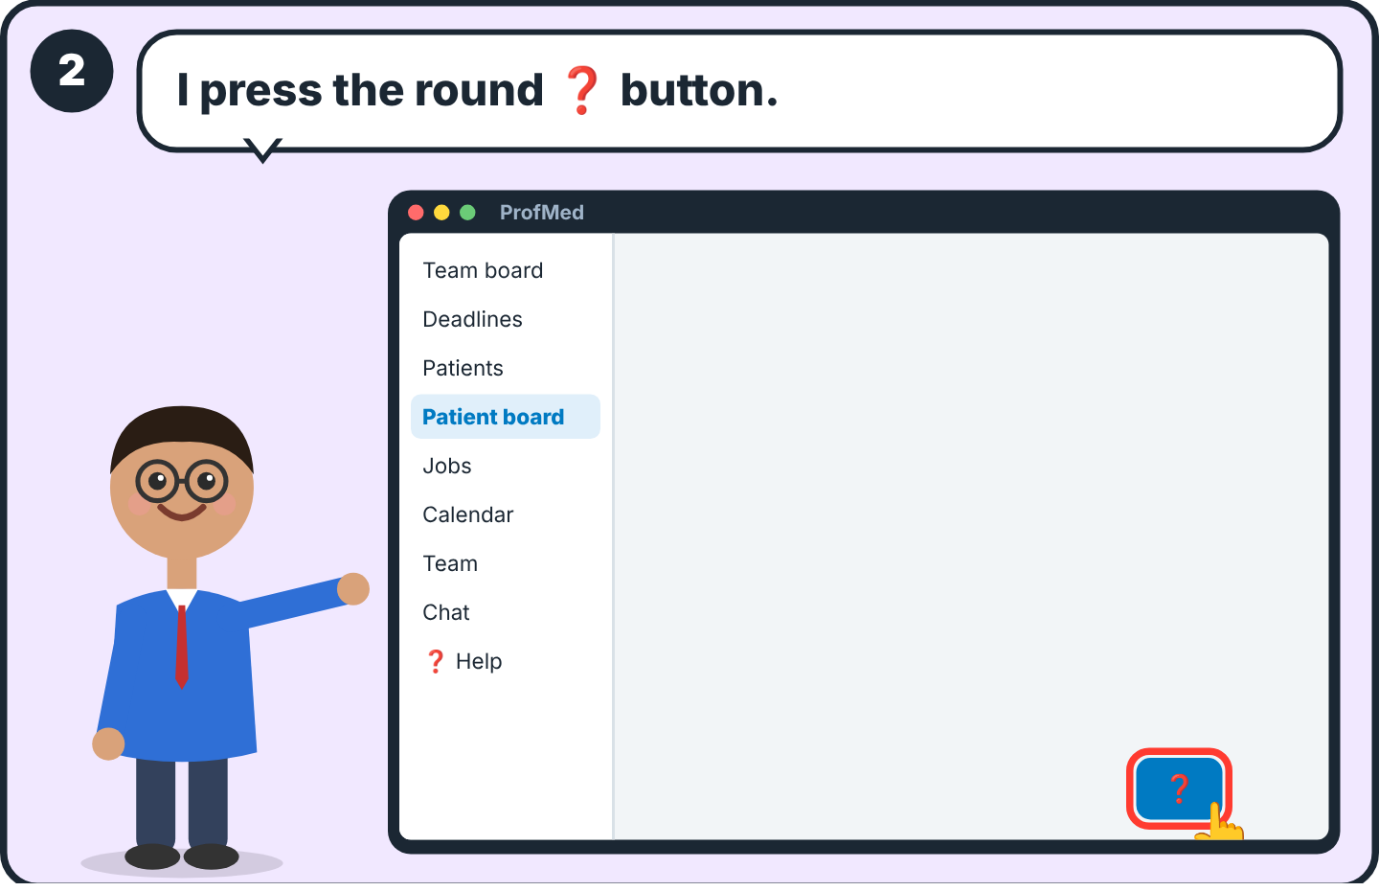  2 Press the round ❓ button at the bottom right. It is on every page.
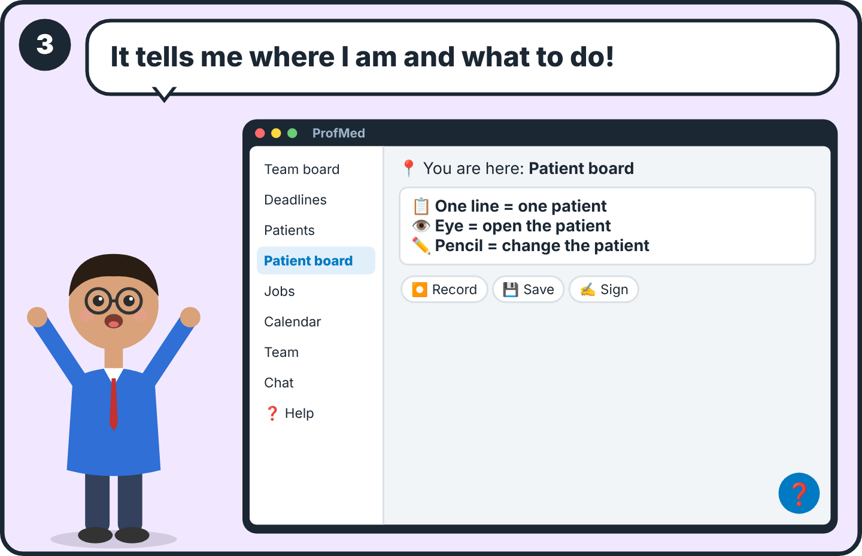
3 You see “You are here” and 3 to 7 short steps with icons. “📚 All help” shows every topic for your job.

🧑‍🦳 Part 3
Add a patient
For: Office

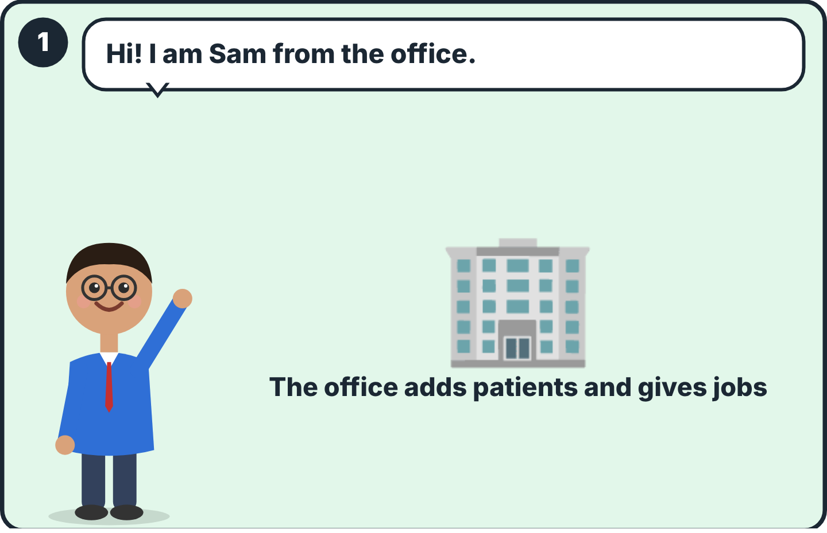  1 Office people (administrator, manager, staff) add patients and give the jobs. | 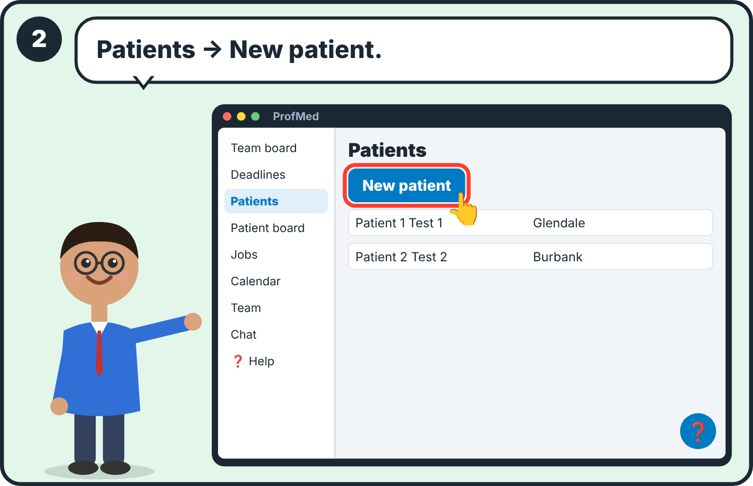  2 In the menu press Patients. Press New patient (top right).
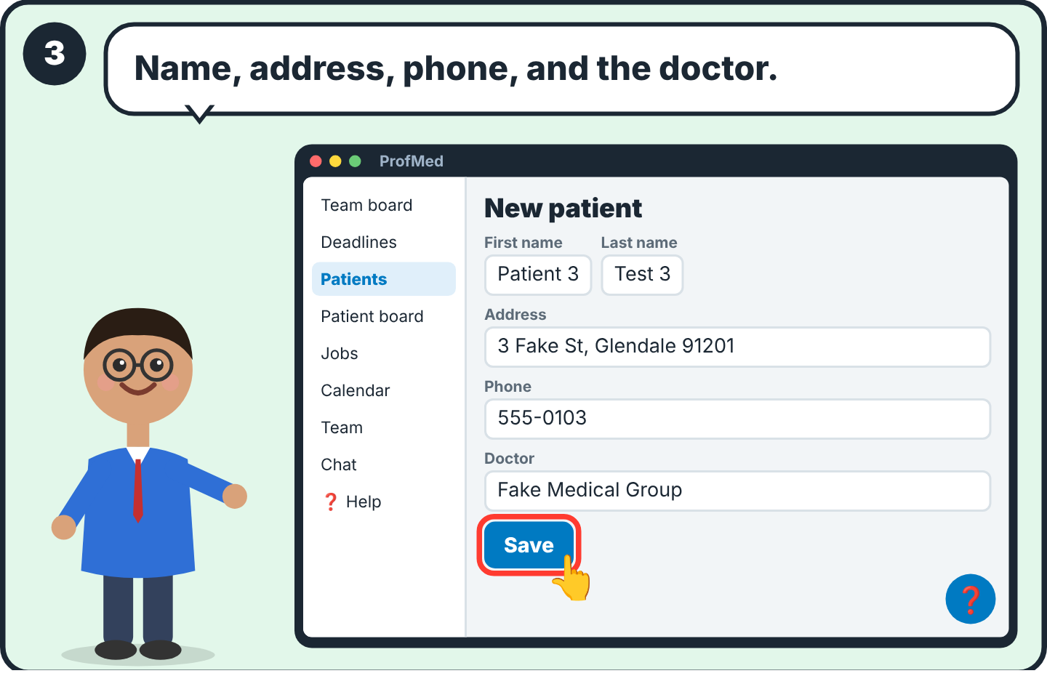  3 Write the name, address, phone and the patient's doctor. Press Save. Check the address: the nurse's check-in is compared to it. | 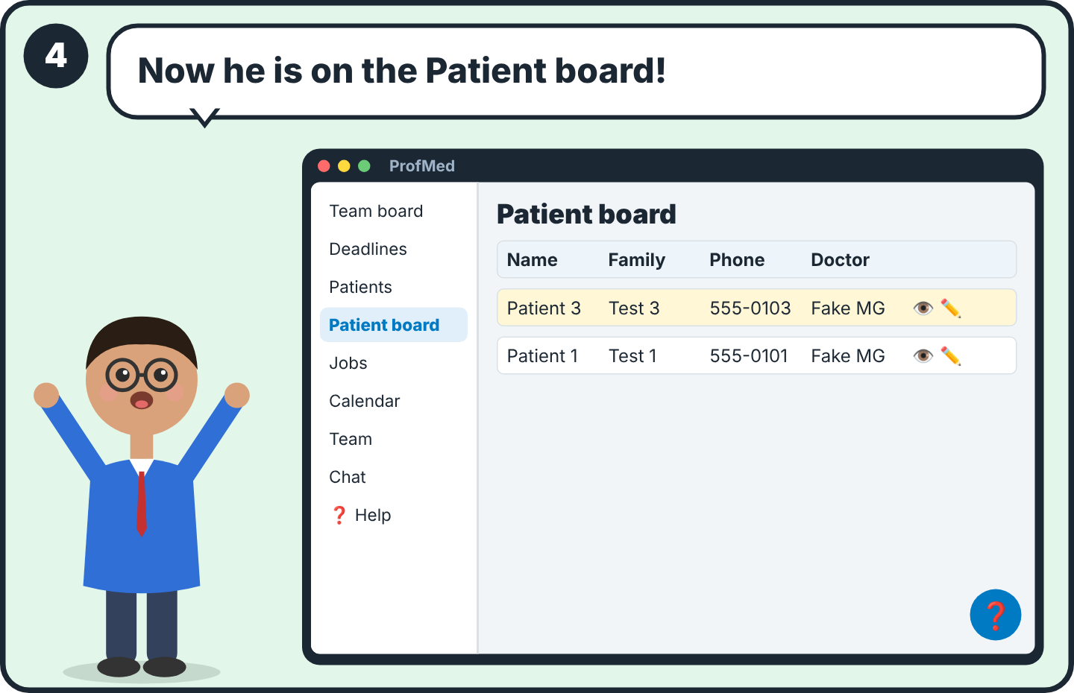  4 Patient board: one line per patient. 👁 opens the patient. ✏️ changes the patient.

📝 Part 4
Give a job to a nurse
For: Office

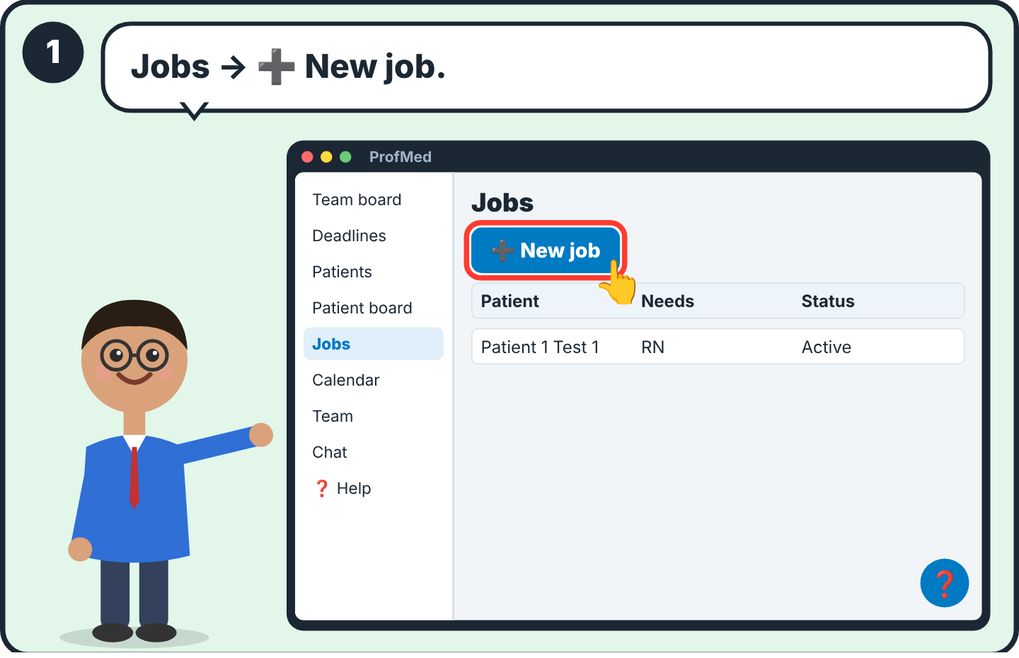  1 Press Jobs, then ➕ New job. | 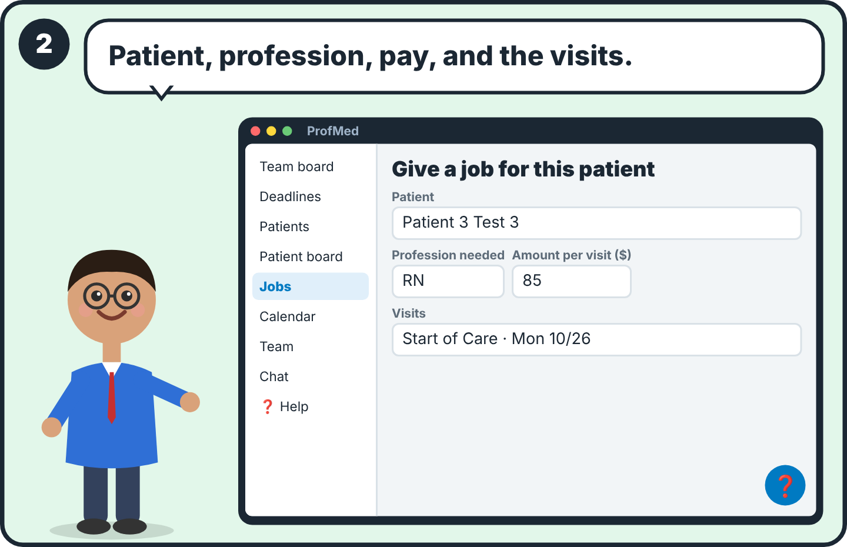  2 Choose the patient, the profession, the amount per visit (the nurse sees it before saying yes), and the visit days and types.
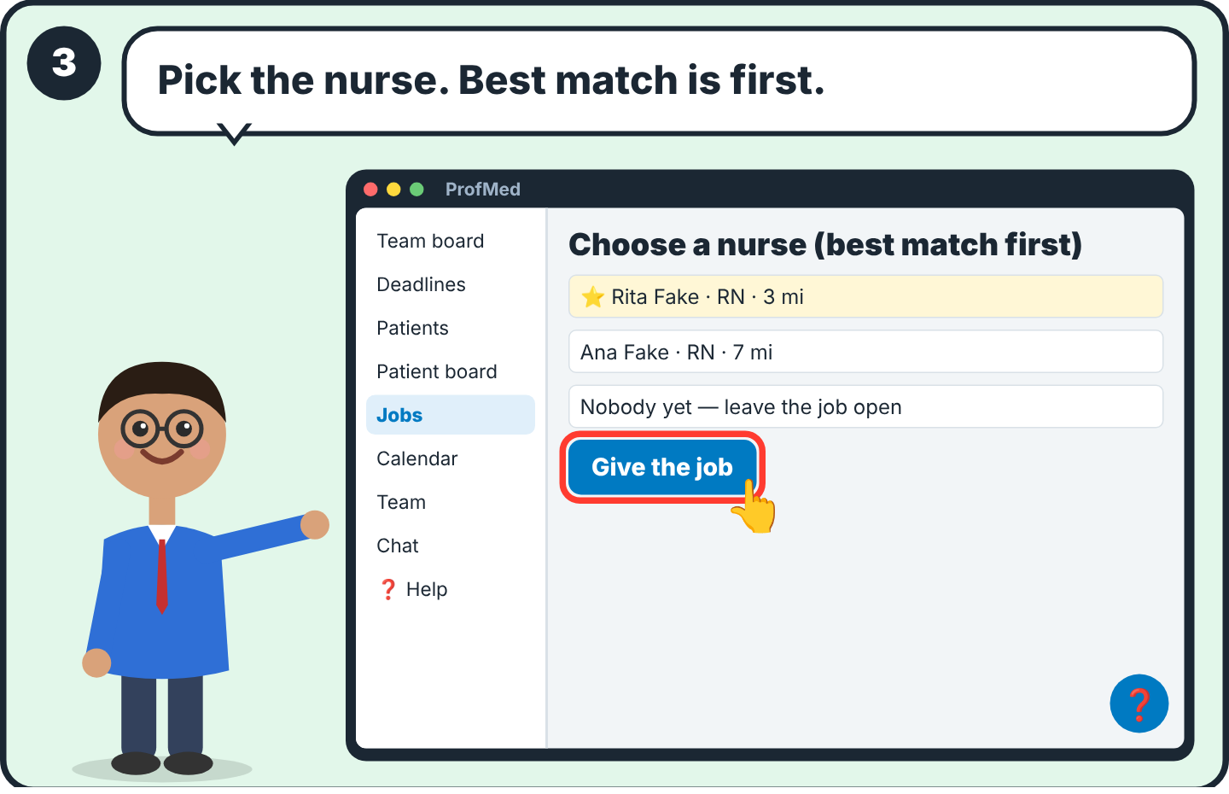  3 Pick a nurse from the list (best match first), or leave the job open. Press Give the job. | 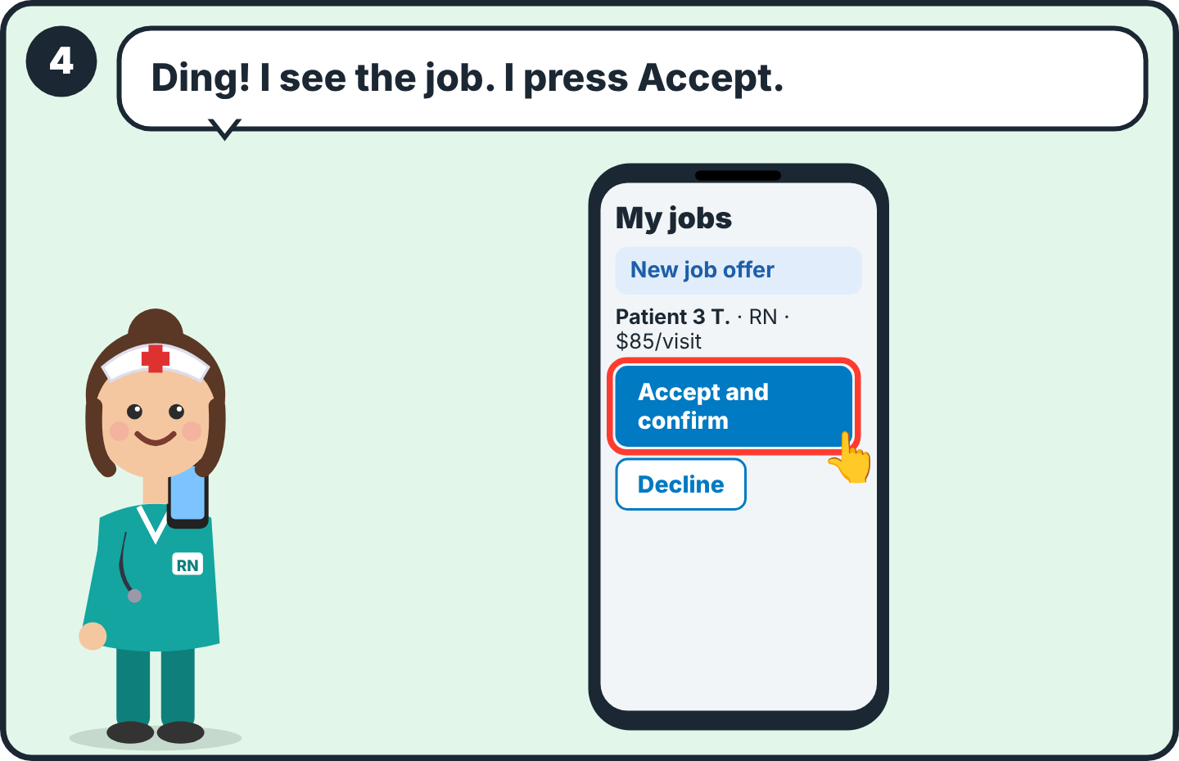  4 The nurse sees the offer in My jobs and presses Accept and confirm. Only then does she see the full patient details.

🧭 Part 5
Watch the day
For: Office

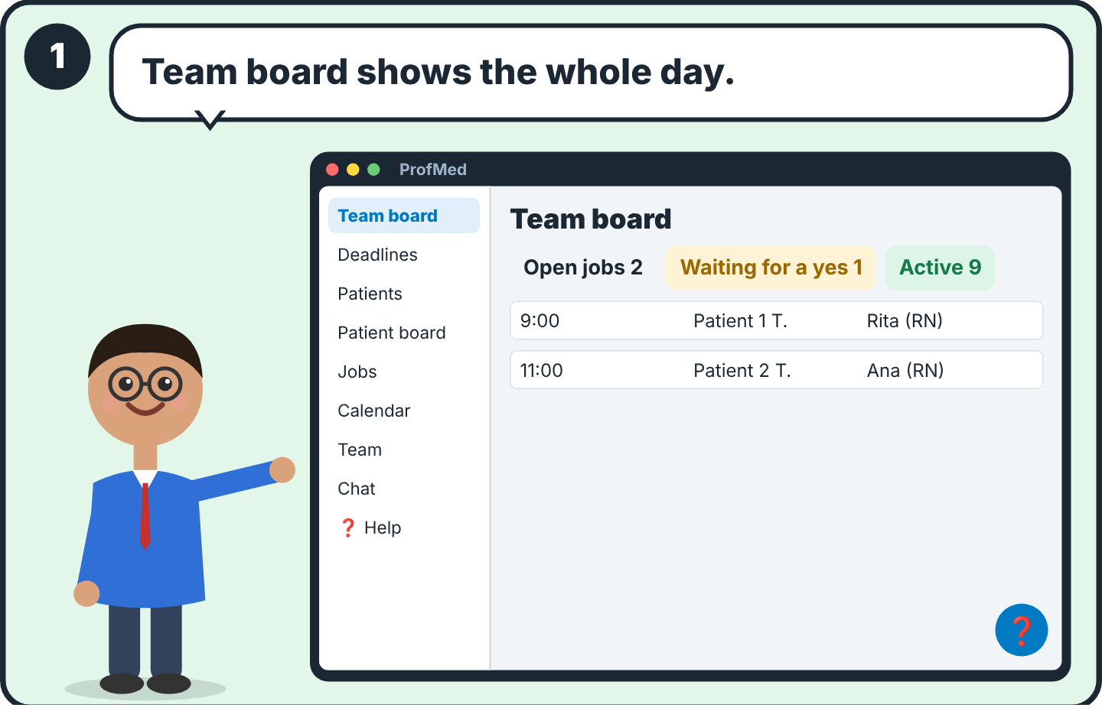  1 Team board: open jobs, jobs waiting for a yes, active jobs, and every visit of the day. Pick another day at the top right. | 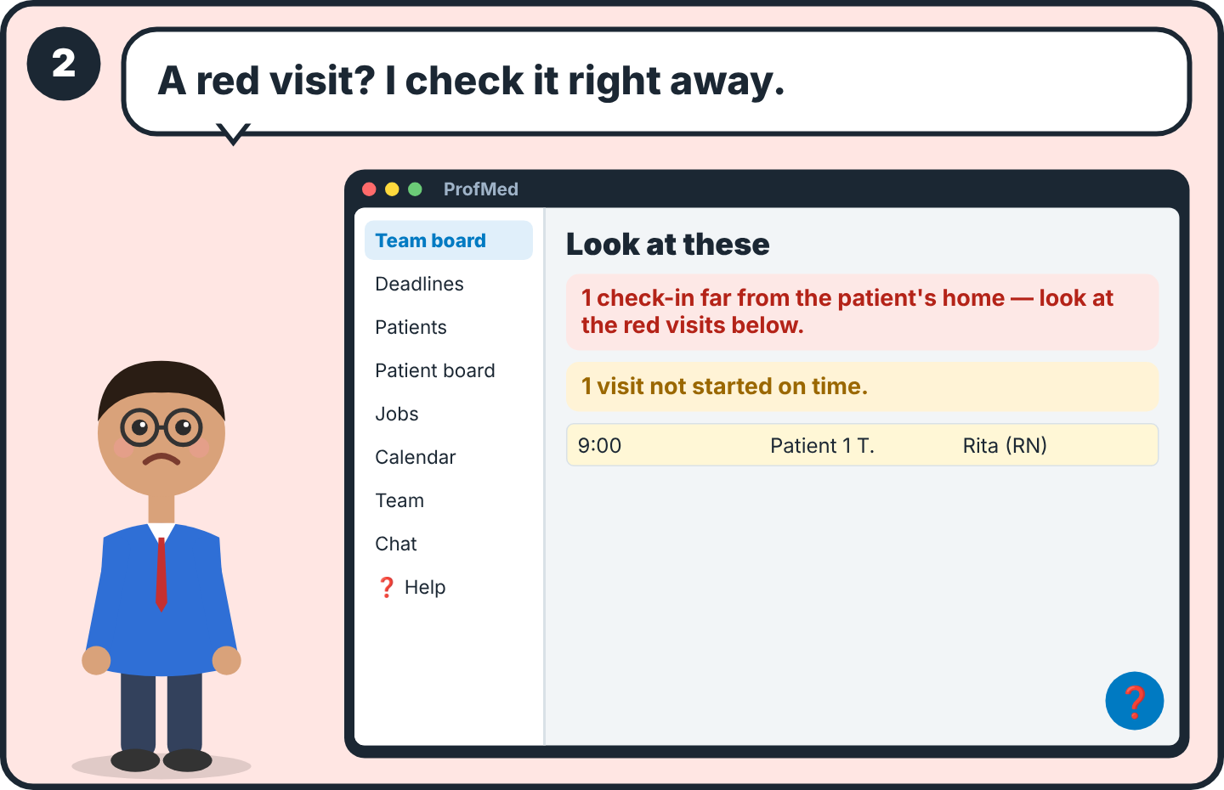  2 Red = the check-in was far from the patient's home. Yellow = a visit did not start on time. Call the nurse.
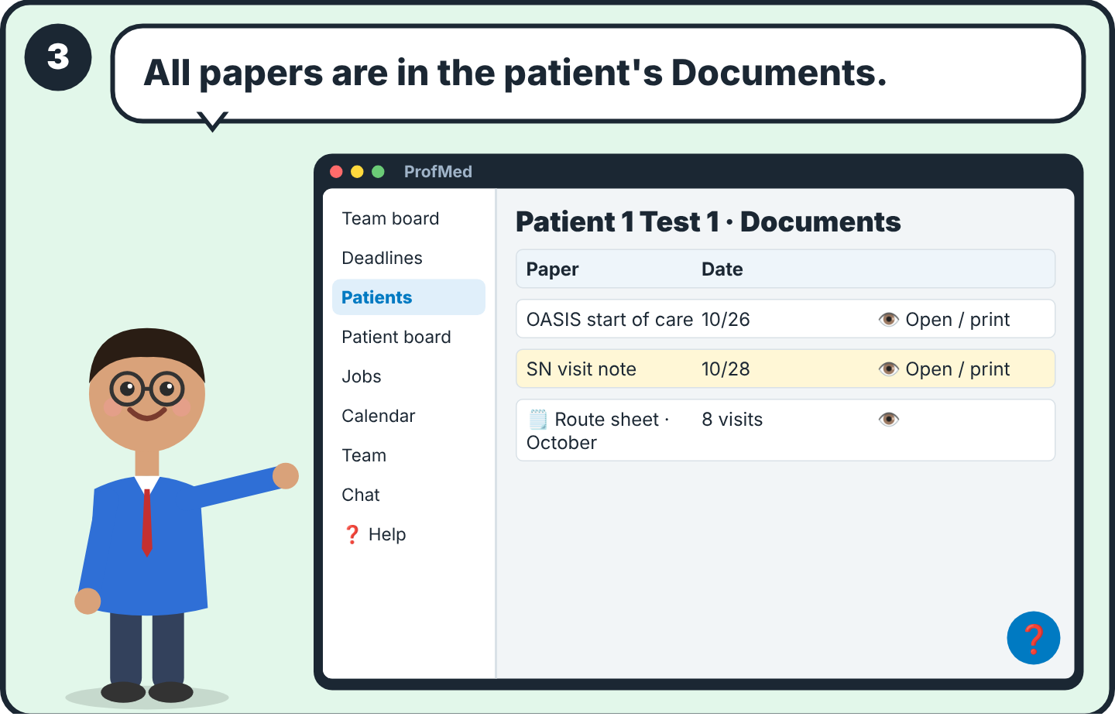
3 Open the patient. In Documents you find every paper (OASIS, notes, 485) and the route sheets. Route sheets are made by themselves; nobody types them.

🩺 Part 6
Your visit, step by step
For: Nurses and therapists

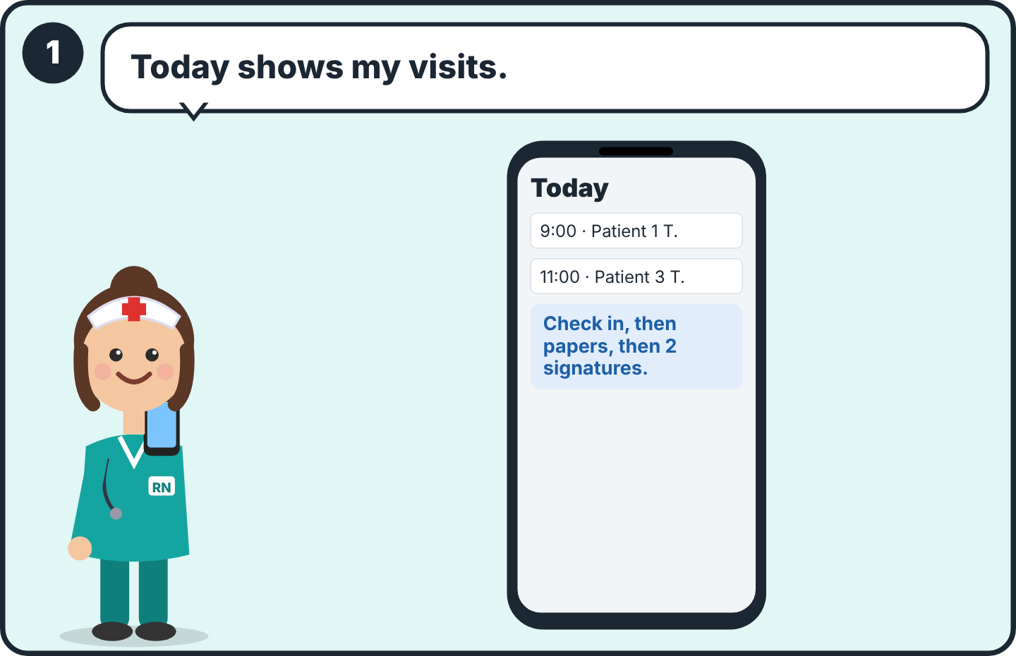  1 Open Today. You see your visits of the day. | 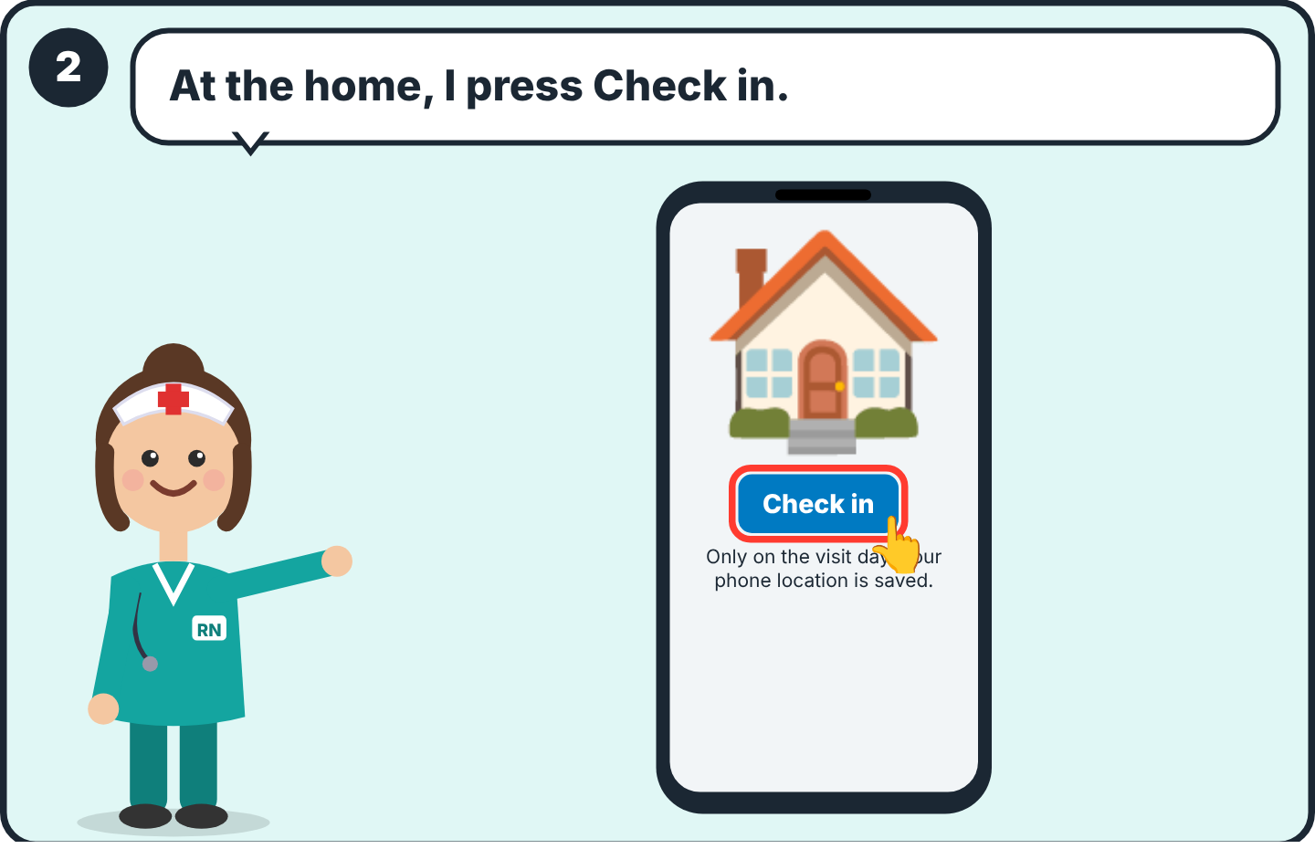  2 Inside the patient's home, press Check in. Allow the location. Check-in works only on the visit day.
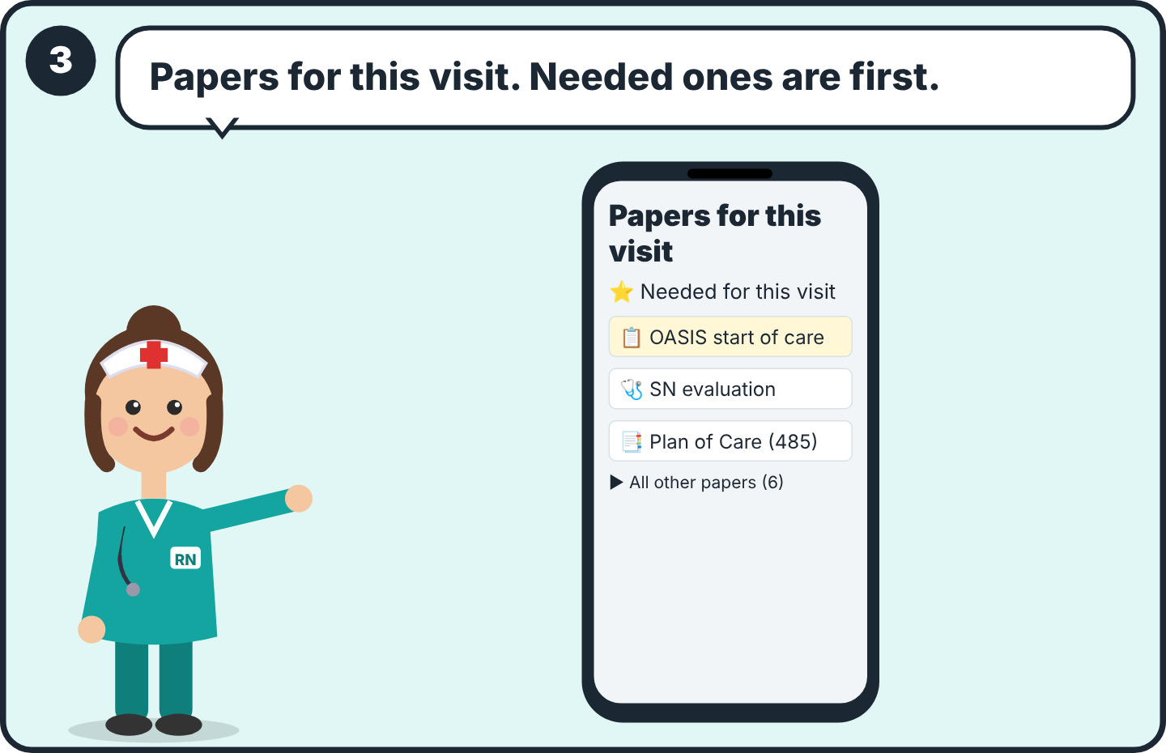
3 Press 📋 Papers for this visit. The papers this visit needs are on top. ✅ = started, ⬜ = empty. Tap a paper.

⏺ Part 7
Fill the paper by voice
For: Nurses and therapists

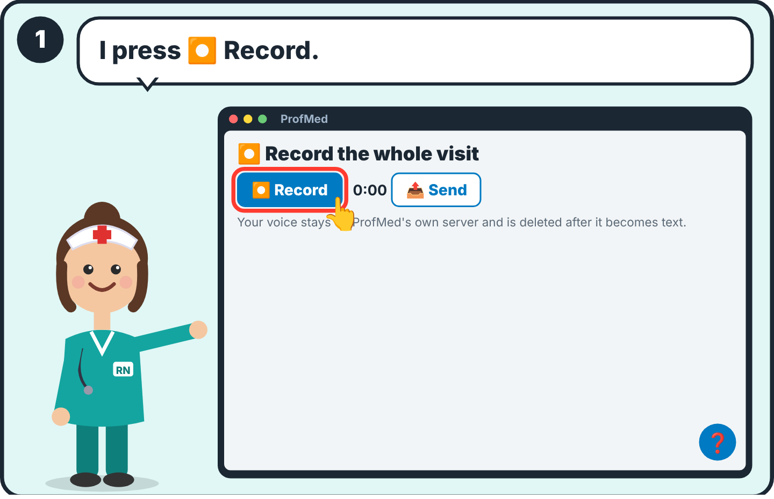  1 Open the paper. Press ⏺ Record. Allow the microphone the first time. | 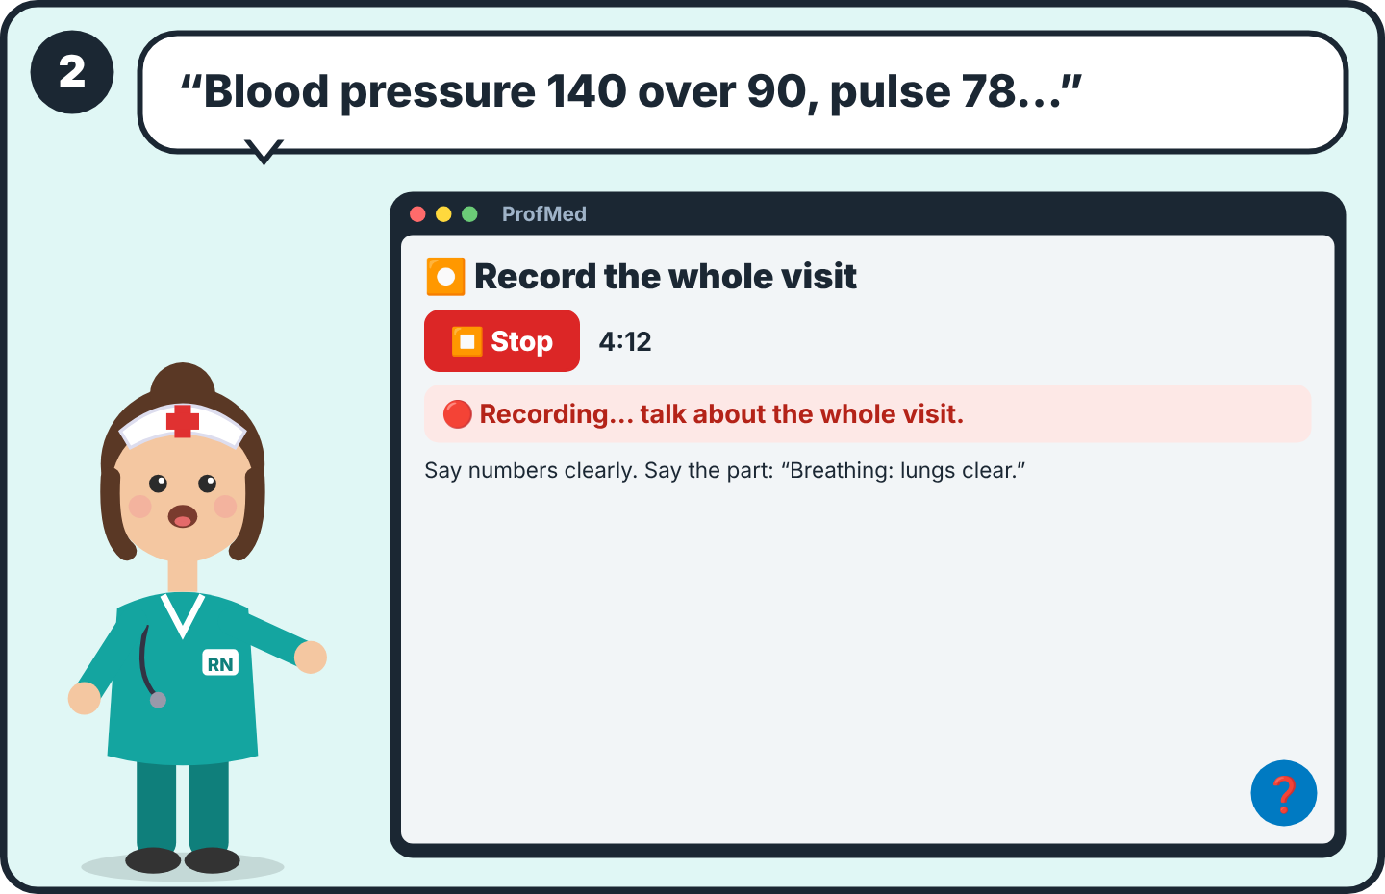  2 Talk about the whole visit, like telling a colleague: vital signs, pain, each body system, what you did and taught. Up to 30 minutes.
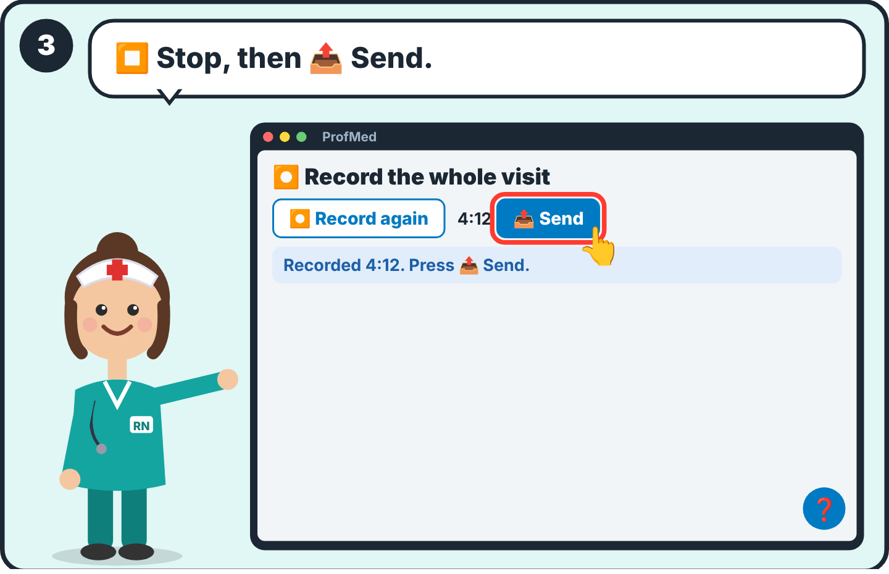  3 Press ⏹ Stop, then 📤 Send. Wait a little: 🎧 = turning your voice into text, 🤖 = filling the paper. Usually a few minutes. | 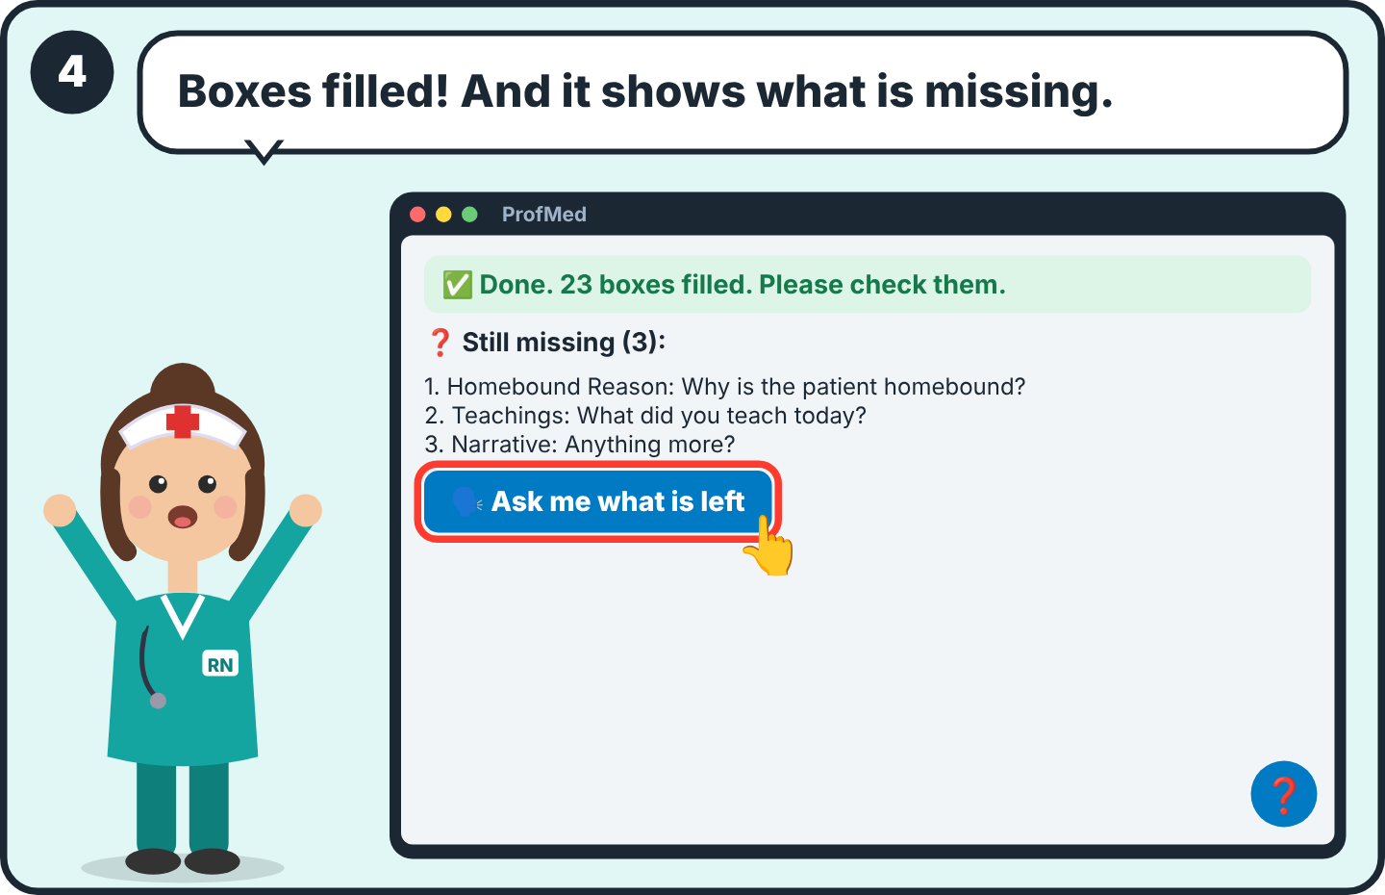  4 You see how many boxes were filled and the list of what is still missing. Boxes you filled yourself are never changed.
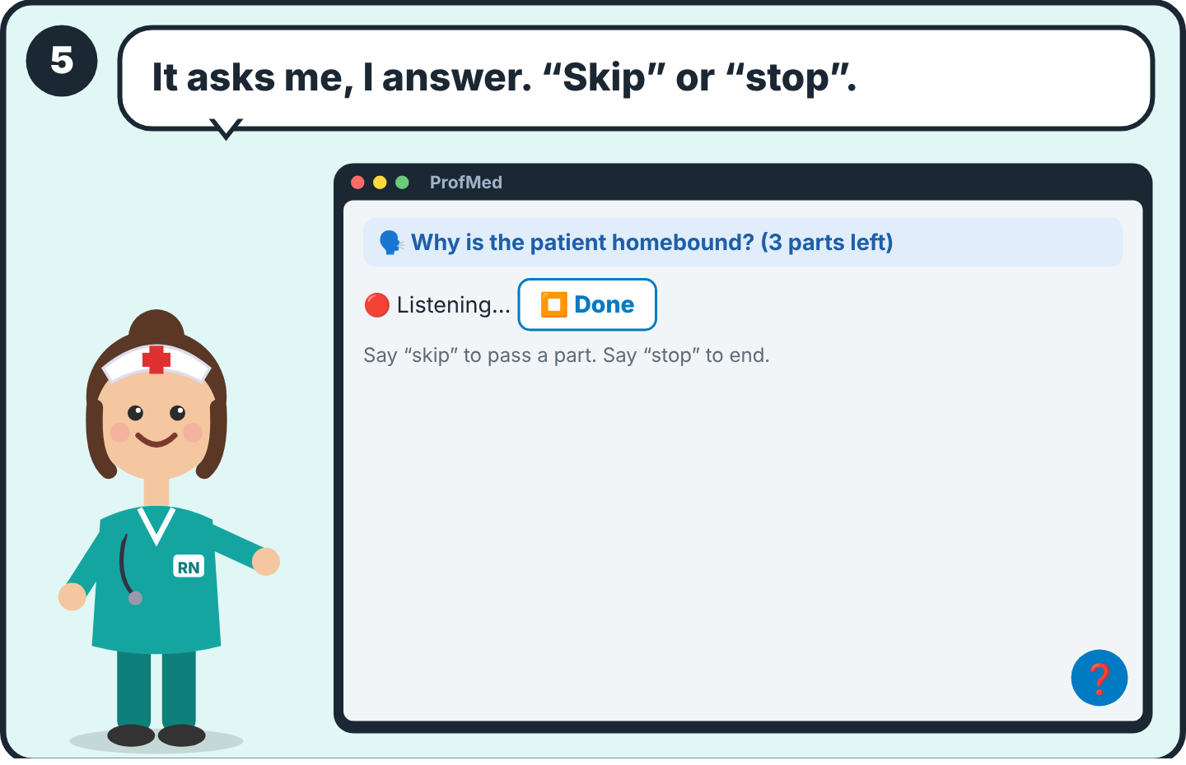  5 Press 🗣 Ask me what is left. ProfMed reads each question aloud. Answer, then press ⏹ Done. Say “skip” or “stop”. Or type the answer. | 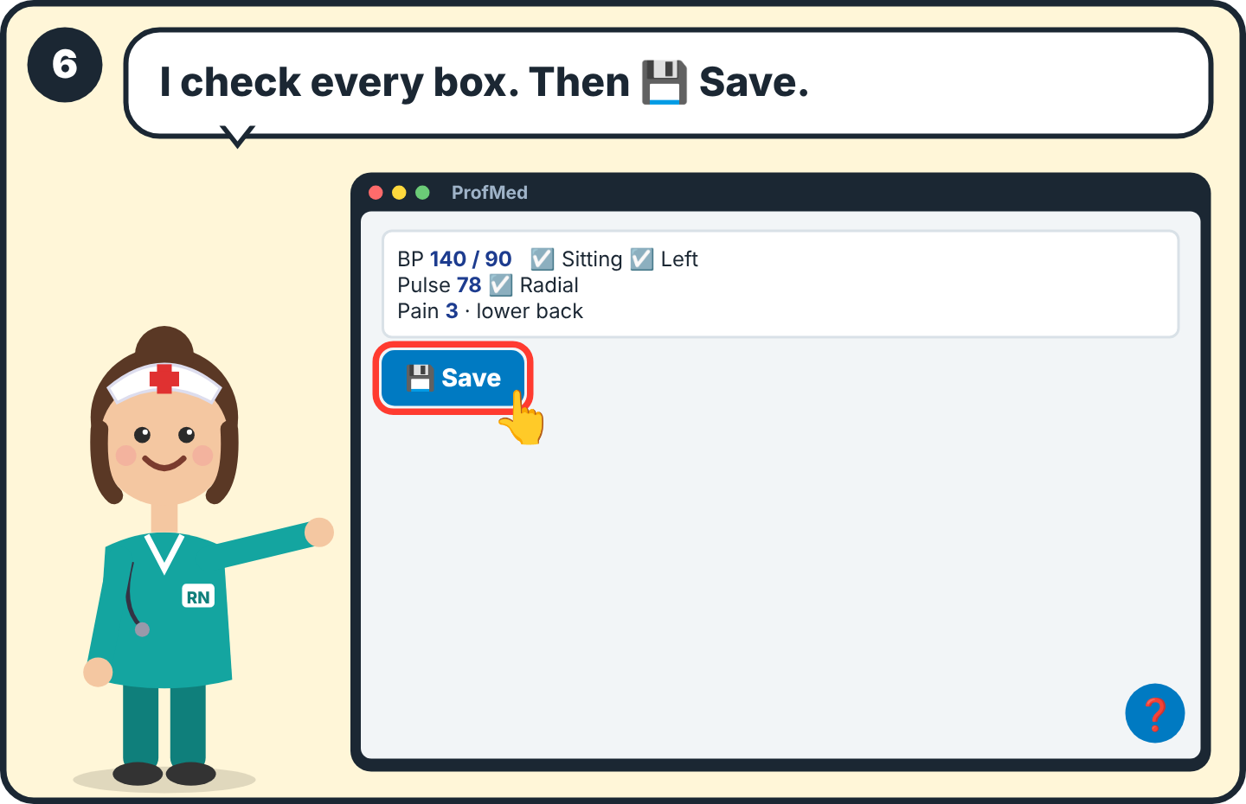  6 Look at the paper. Tap a box to change it. Press 💾 Save. The paper is yours: you check it, you sign it.

🧍 Part 8
OASIS: 5 big questions
For: Nurses and therapists

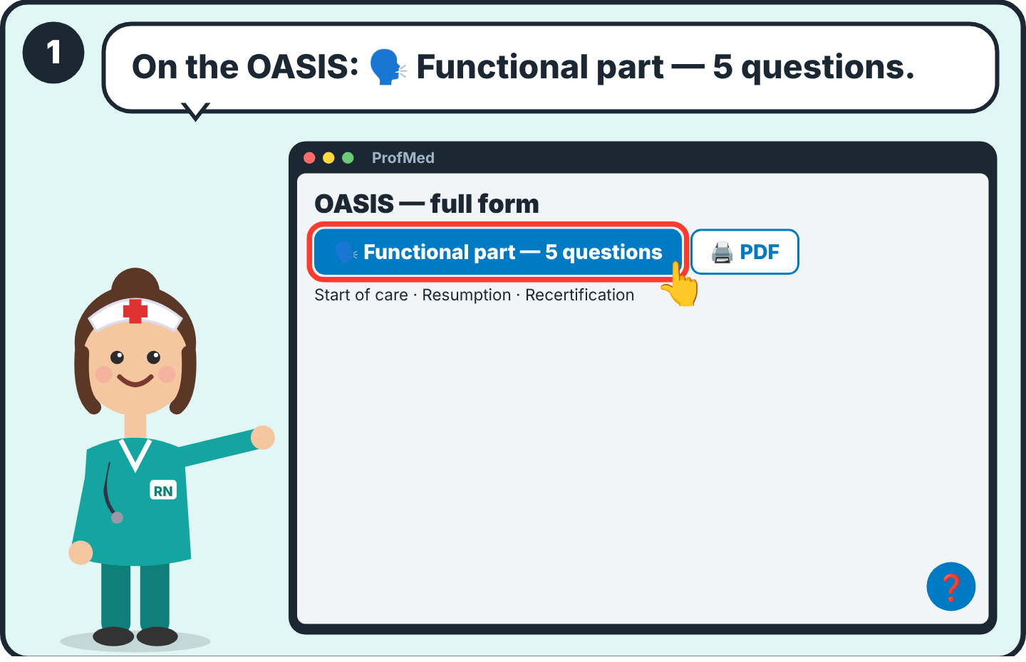  1 On the OASIS start of care, resumption or recertification, press 🗣 Functional part — 5 questions. | 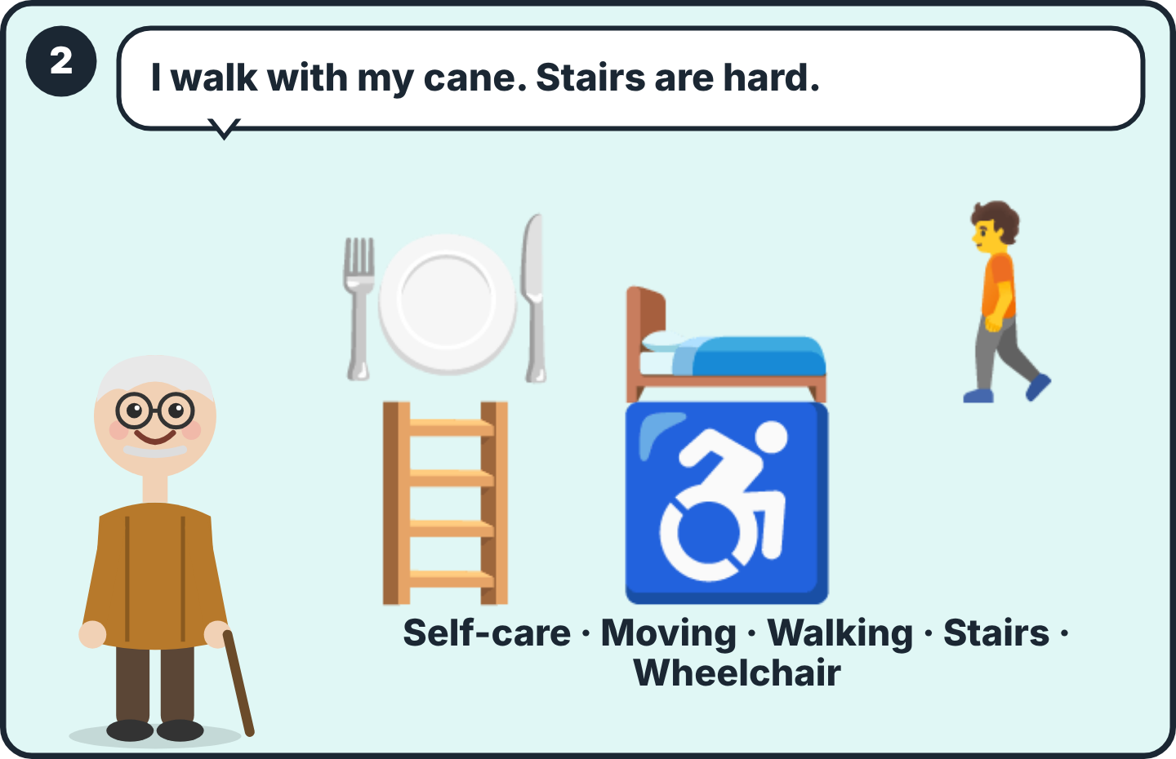  2 Five questions instead of 40 lines: self-care, moving in bed and transfers, walking, stairs, wheelchair.
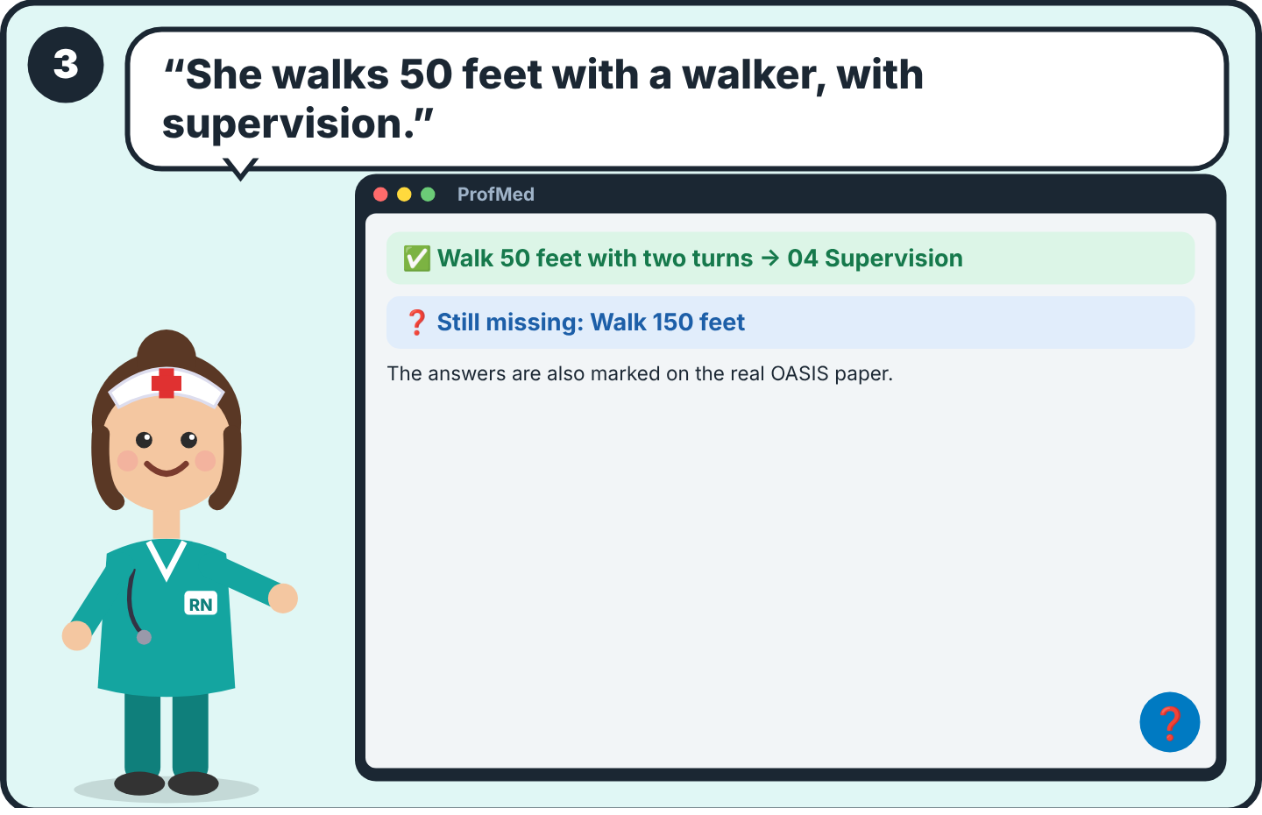
3 One answer fills many items. ProfMed asks only what is missing. The scores are your decision: check them.

✍️ Part 9
Two signatures, then done
For: Nurses and therapists

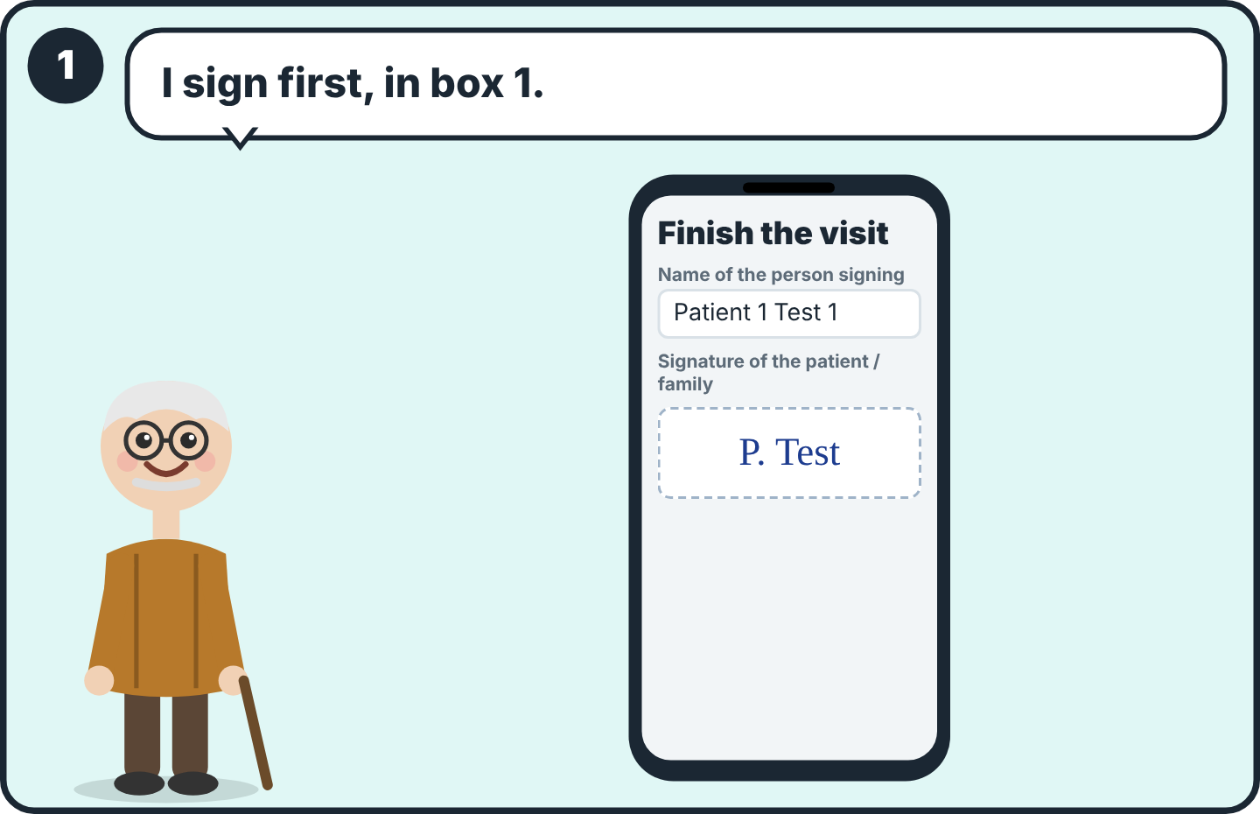  1 Press Finish the visit. Write the name of the person signing. The patient or family signs in box 1. | 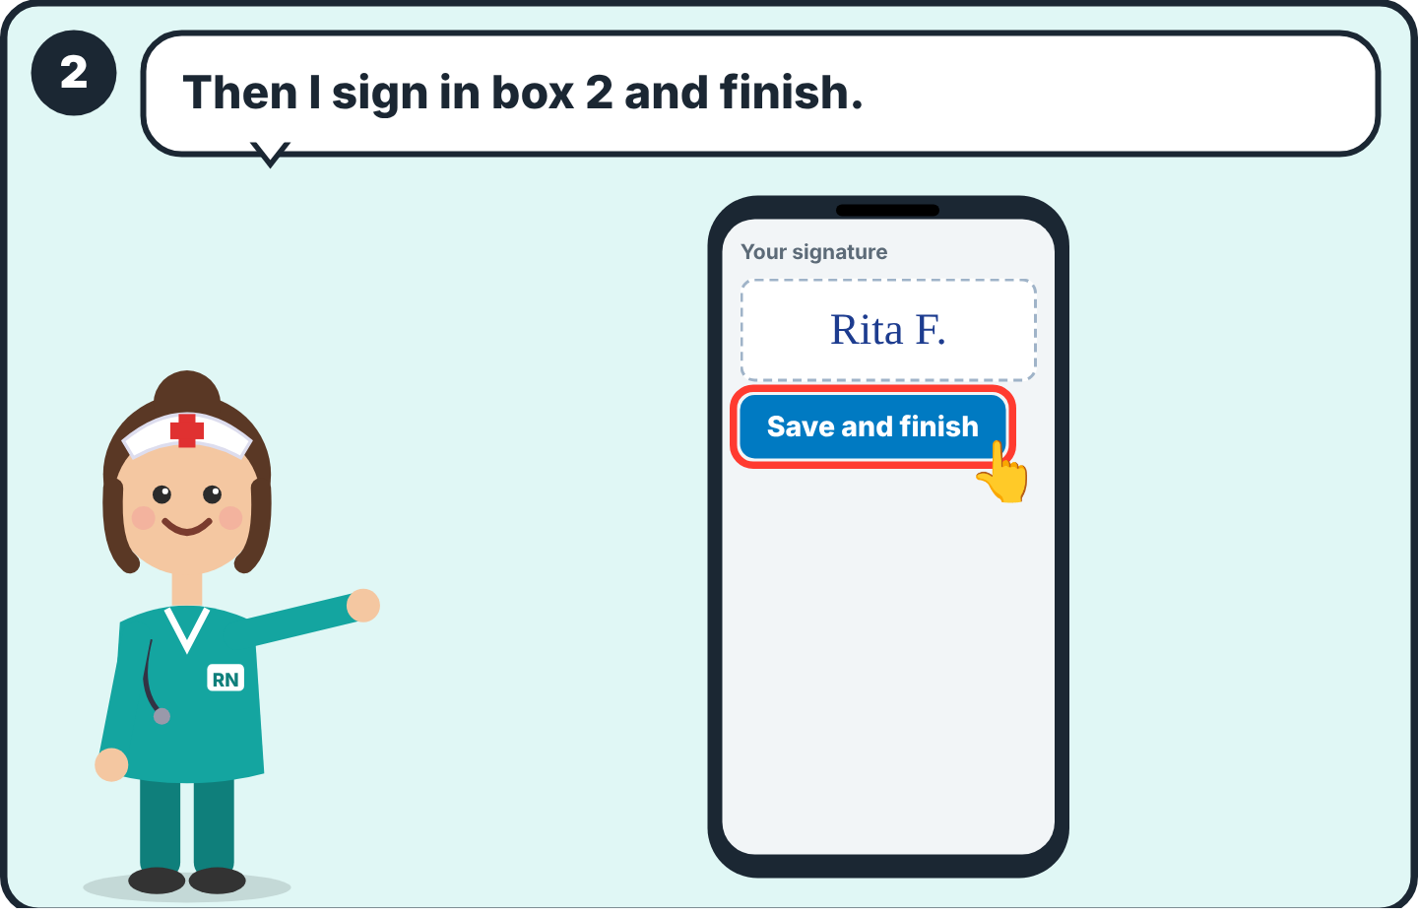  2 You sign in box 2. Press Save and finish.
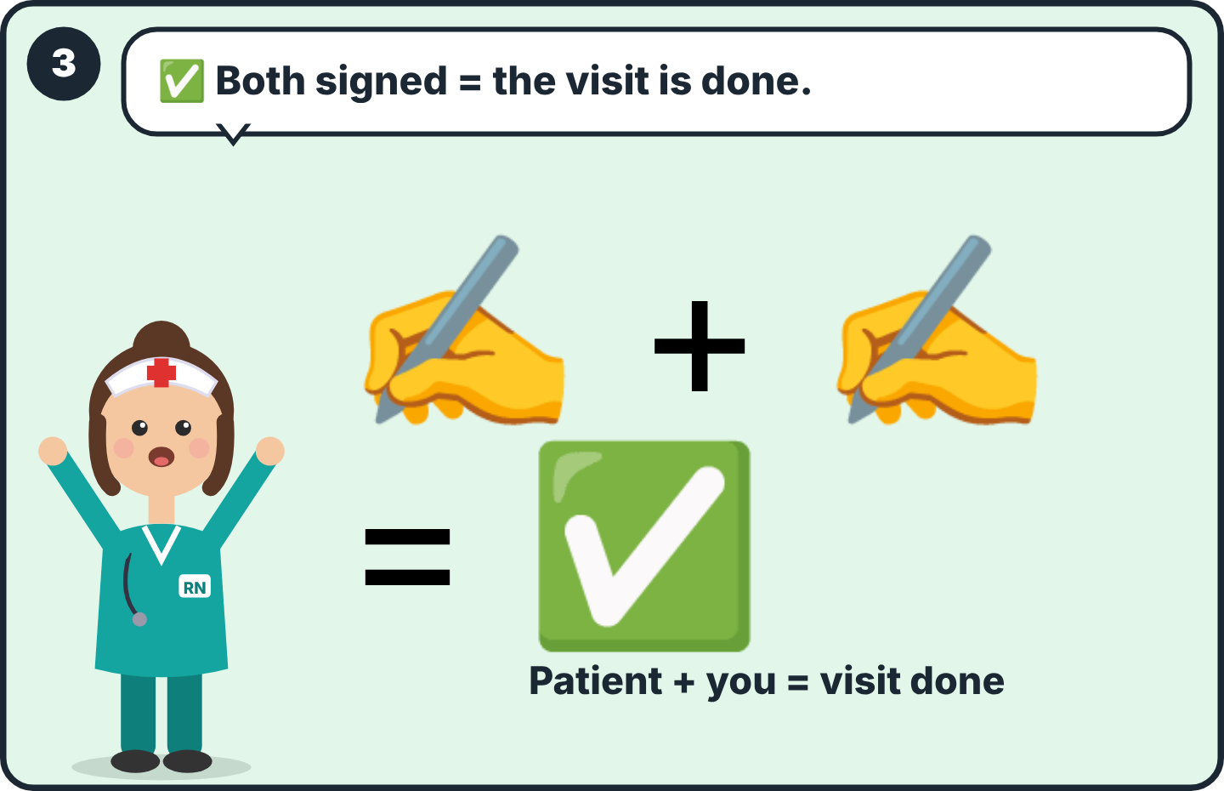  3 A visit is done only with BOTH signatures. Then the papers lock 🔒. Check the papers before you sign. | 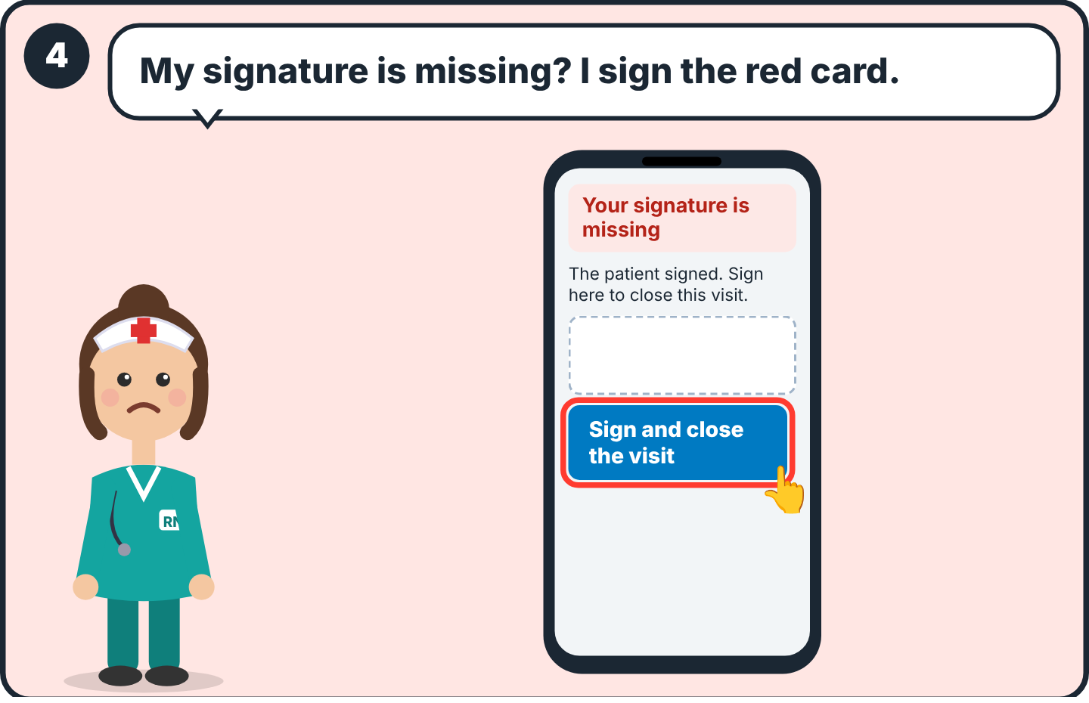  4 If only the patient signed, a red card “Your signature is missing” appears on the visit. Sign there to close it.

🛡 Part 10
10 rules to avoid mistakes
For: Everyone

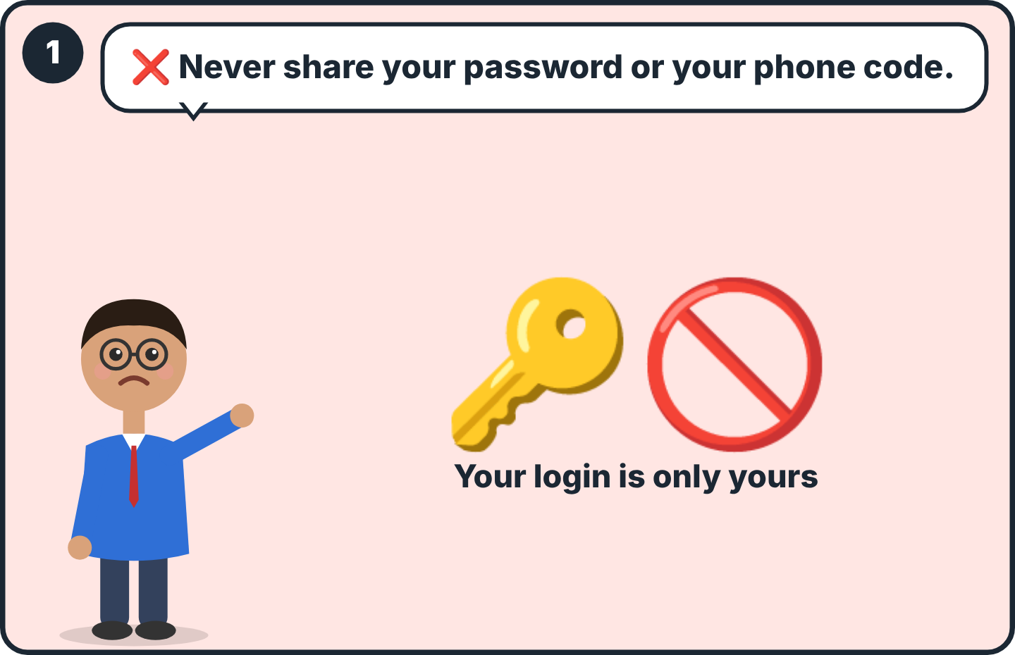  1 Your password and your 6-digit code are only yours. ProfMed will never ask for them. | 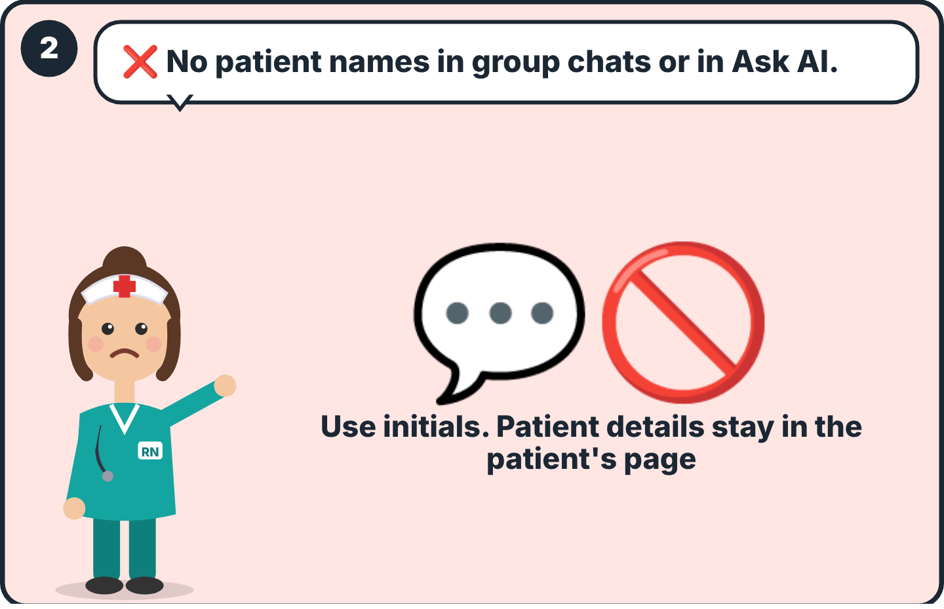  2 In group chats and in “Ask ProfMed AI”, never write patient names or details.
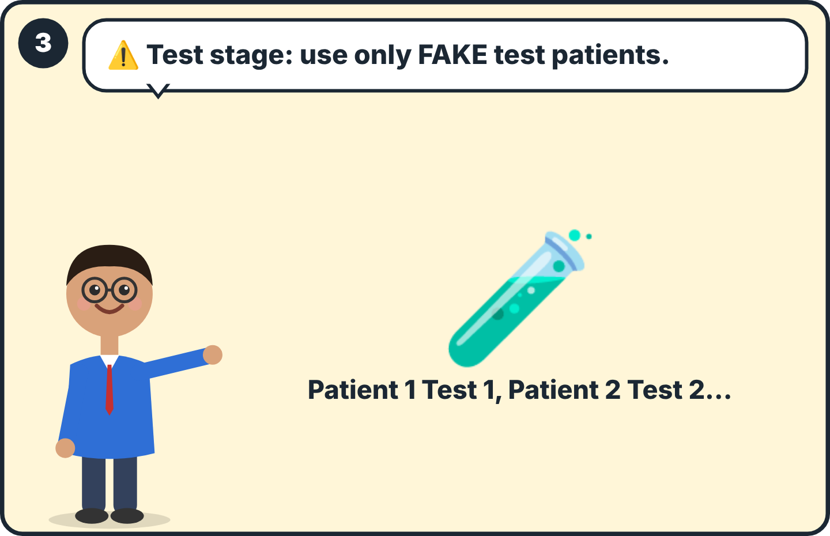  3 Until ProfMed tells you the HIPAA setup is finished, use only fake test patients. | 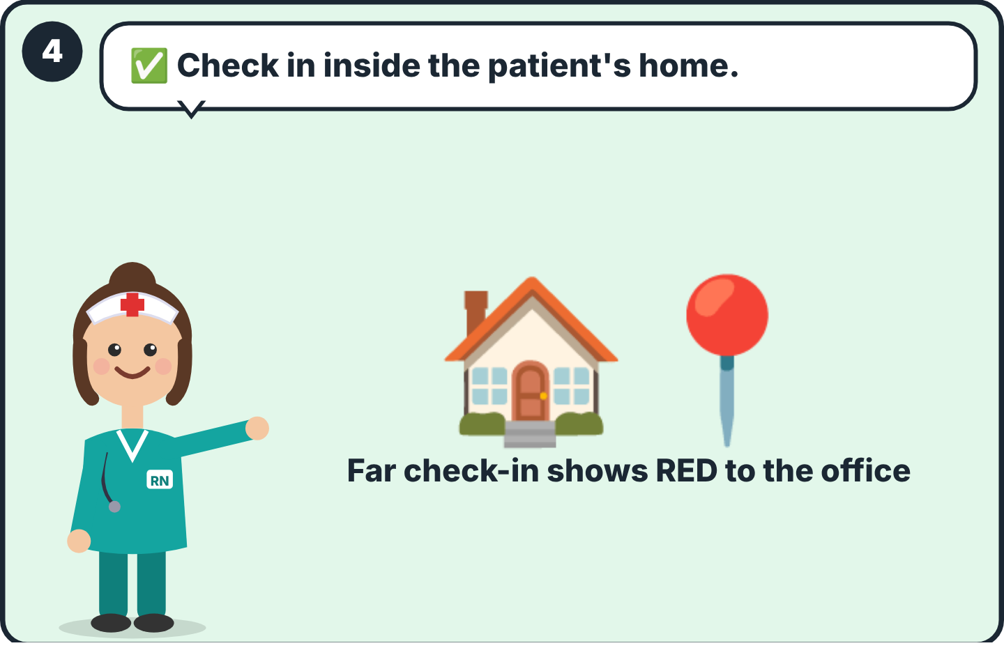  4 Check in only when you are at the patient's home. A far check-in is shown in red.
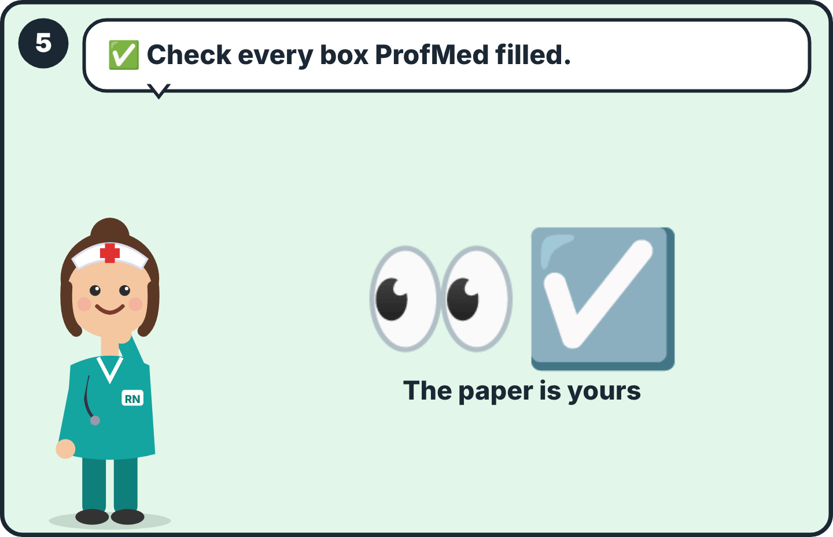  5 The voice and the AI help you. You are responsible for the paper. Check before Save and before signing. | 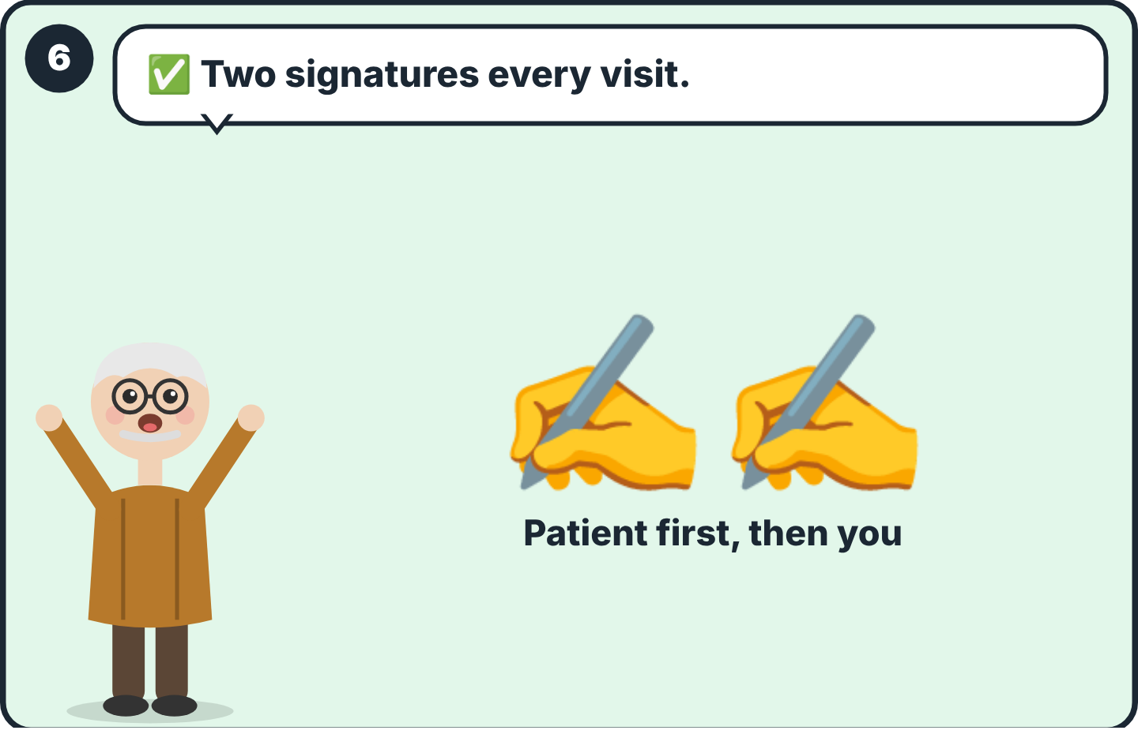  6 No visit is done without both signatures.
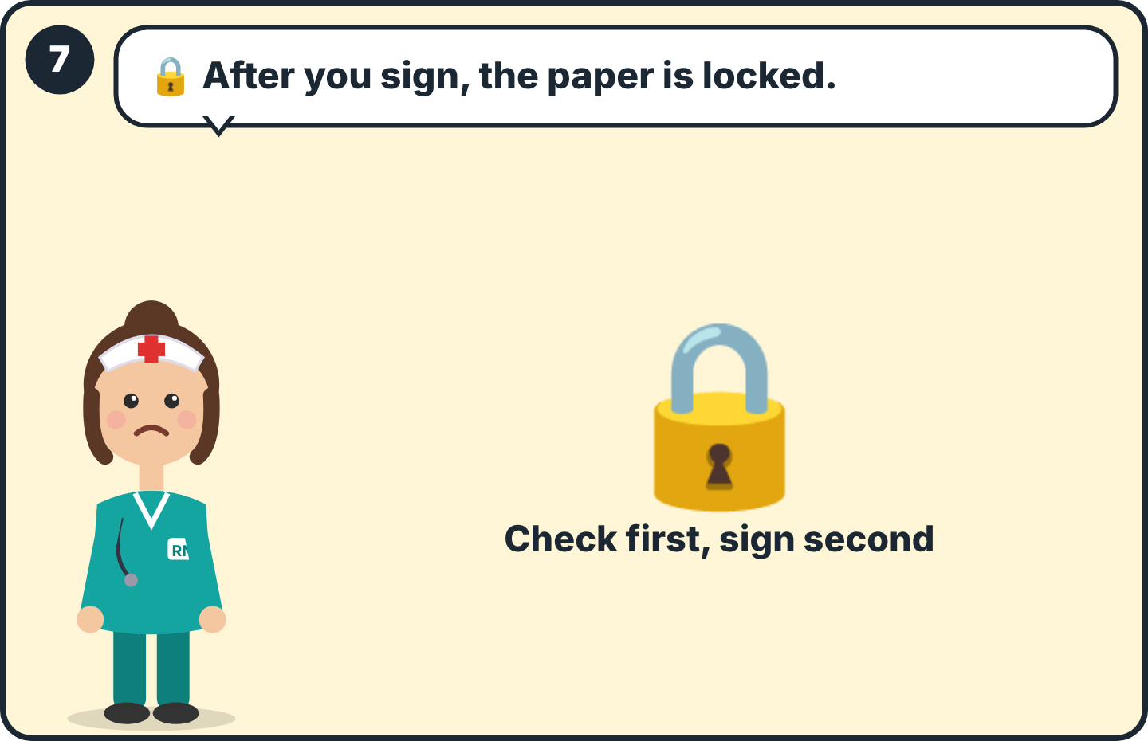  7 Signed papers cannot be changed. Tell the office if something must be corrected. | 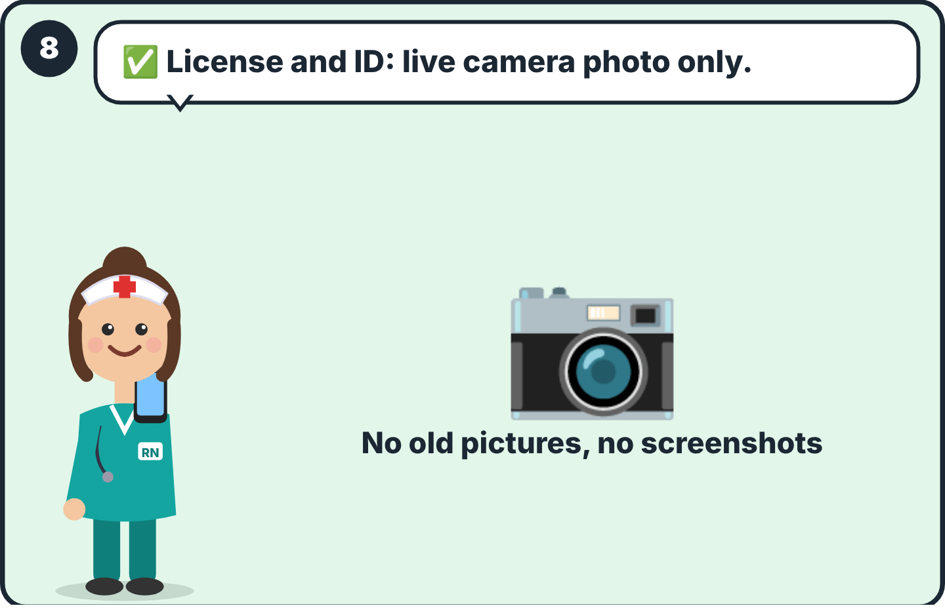  8 Upload your license and ID only with a live camera photo.
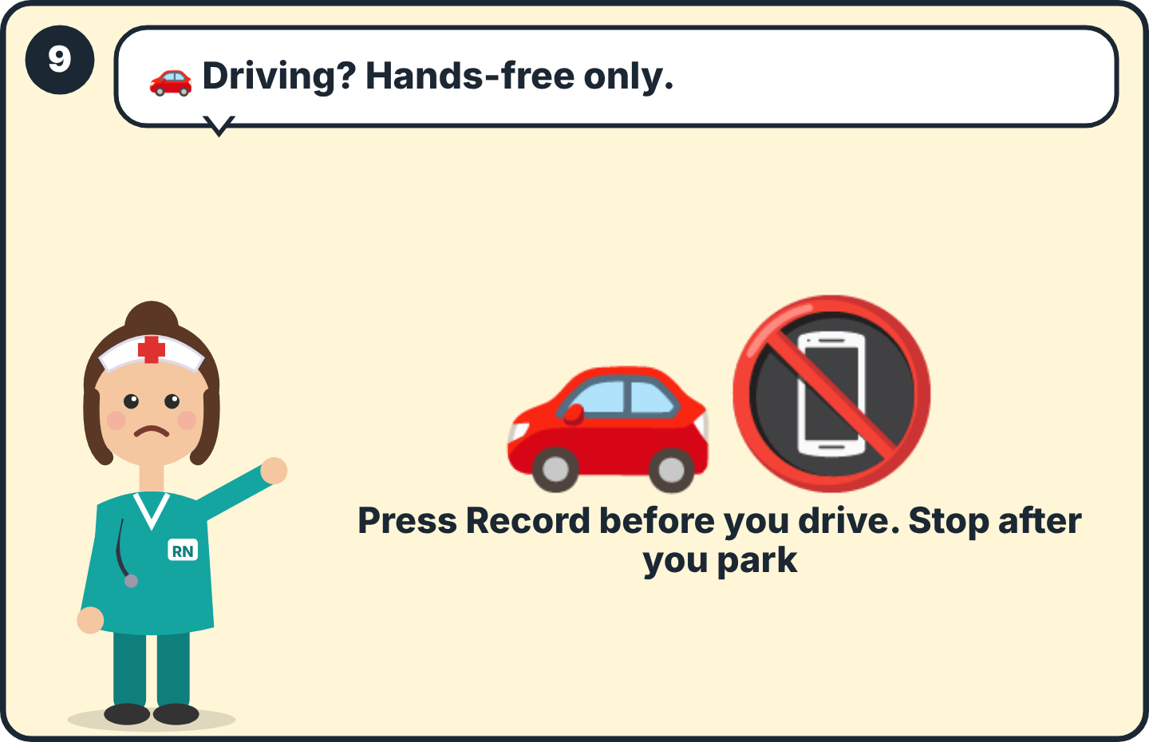  9 Do not touch the phone while driving. Press Record before you start the car and Stop after you park, or record after the visit. | 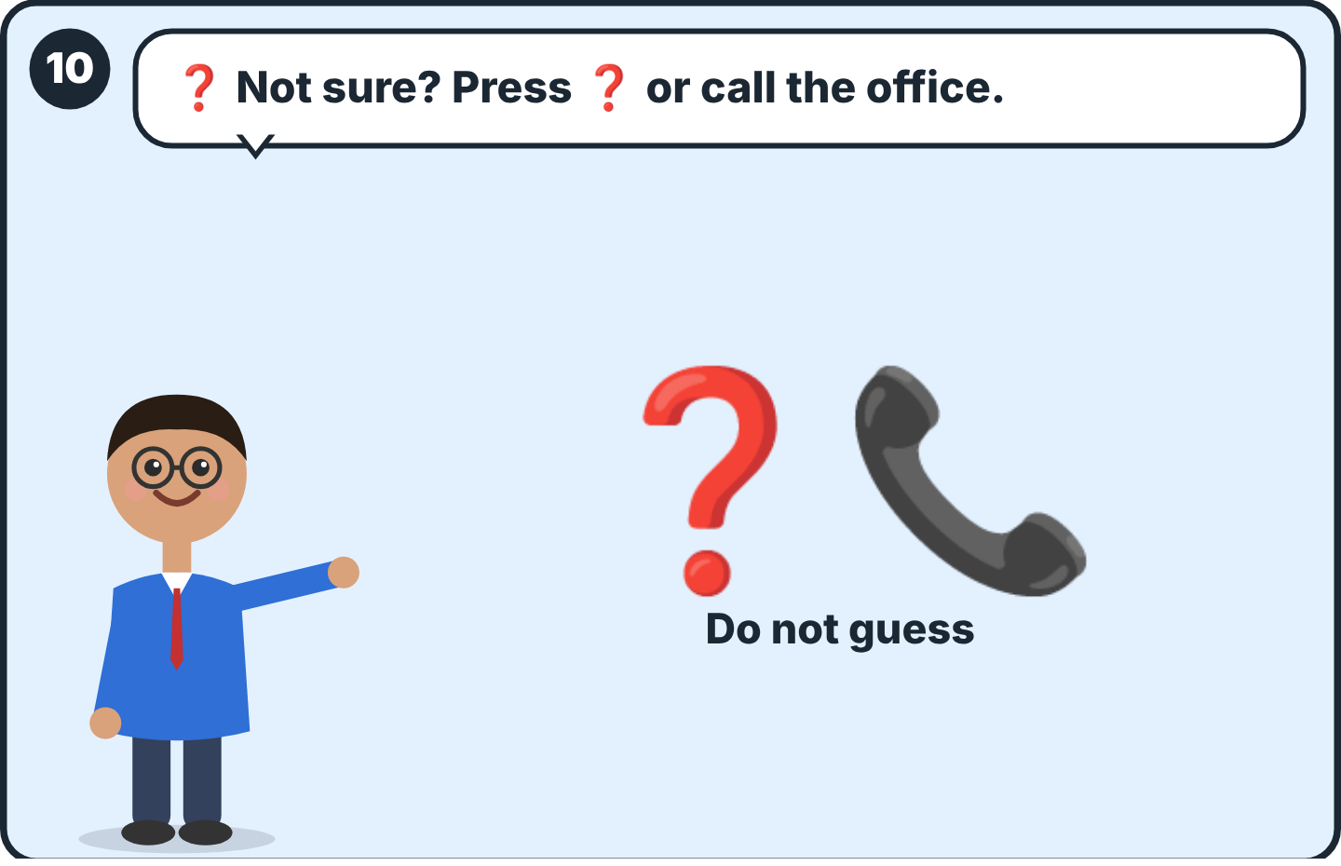  10 If you are not sure, press ❓, or call your office. A question is better than a mistake.

🔤 Part 11
The signs
For: Everyone

⏺ | Record | ⬜ | Empty
⏹ | Stop | 🔒 | Locked
📤 | Send | ⏭ | Skip
🎤 | Speak (test patients only) | 🗣 | ProfMed asks you
⚡ | Fill | 🖨 | Print / PDF
💾 | Save | ❓ | Help
👁 | Open | ⭐ | Needed for this visit
✏️ | Change | 🔴 | Problem / recording
✍️ | Sign | 📍 | You are here / location
✅ | Done / started | ↩️ | Back
My office phone: ______________________
My office contact person: ______________________

